Demo starwars

<http://wirebeings.com/star-wars-augmented-reality.html>

Load assets

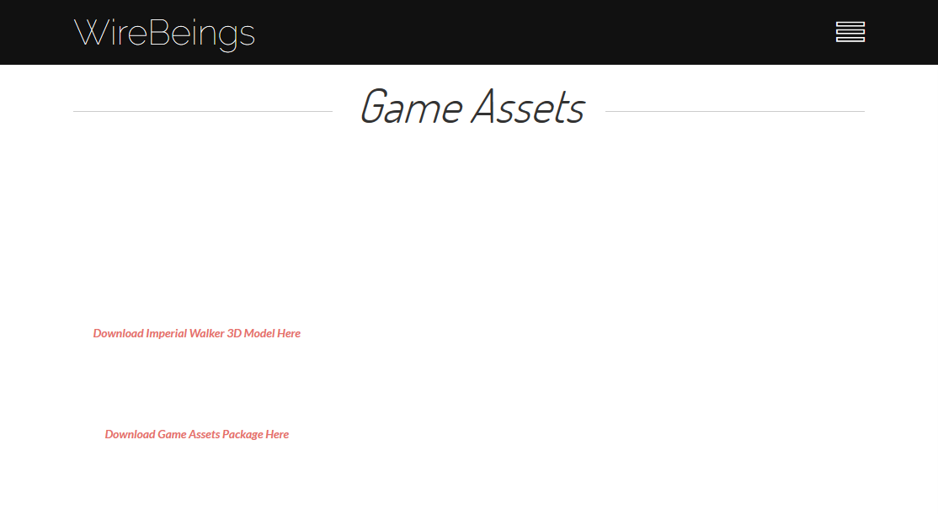

New link : [https://www.cgtrader.com/free-3d-models/space/spaceship/at-at-0ec13812d08eb1b6d46717e726cac367﻿](https://www.cgtrader.com/free-3d-models/space/spaceship/at-at-0ec13812d08eb1b6d46717e726cac367)

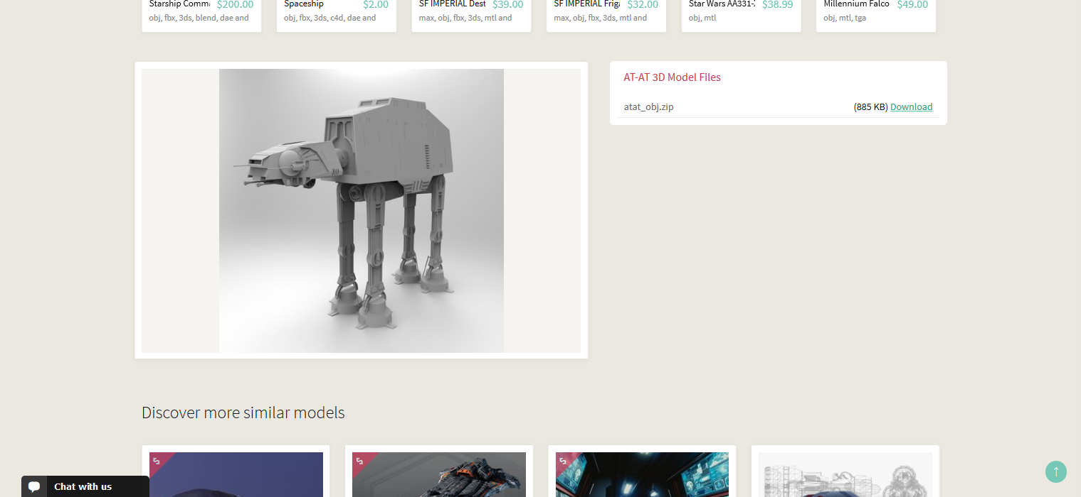

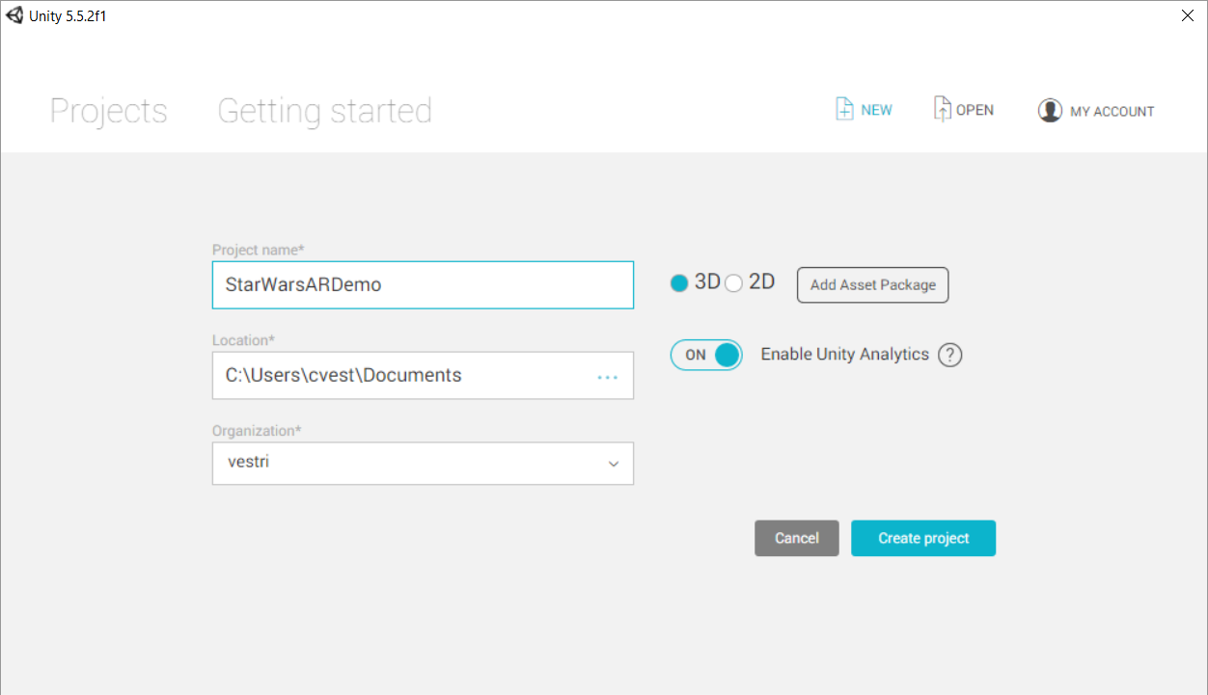

CReate new project

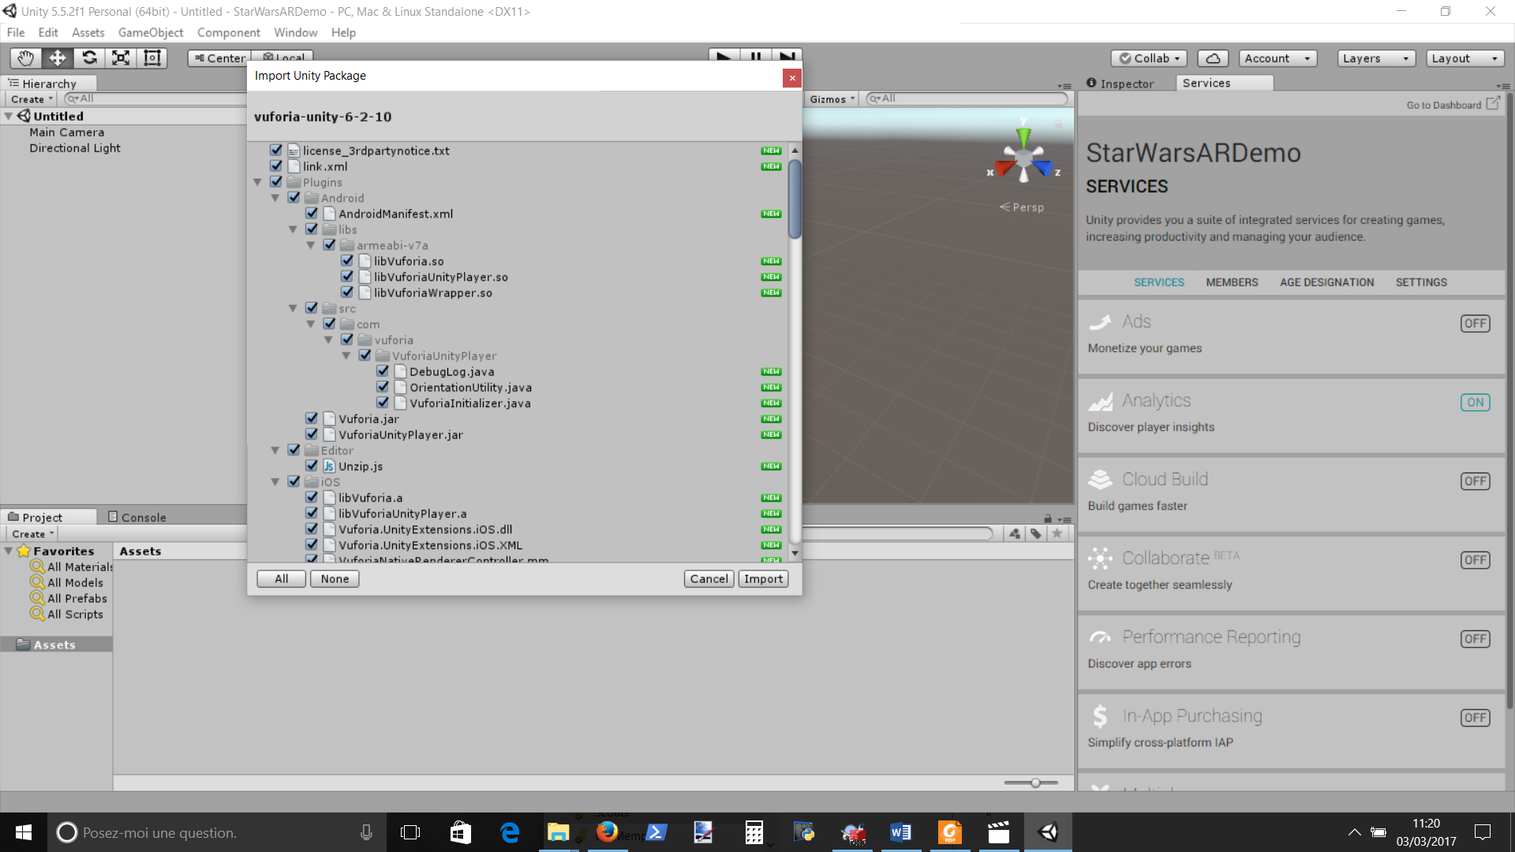

Add vuforia package

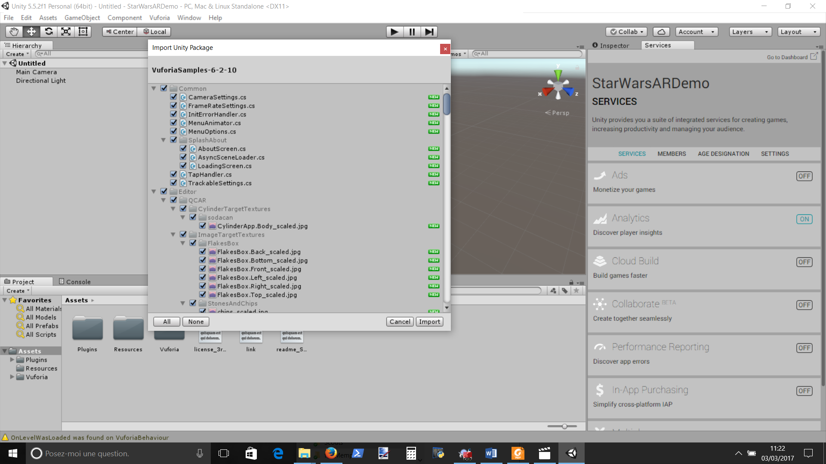

Add vuforia samples

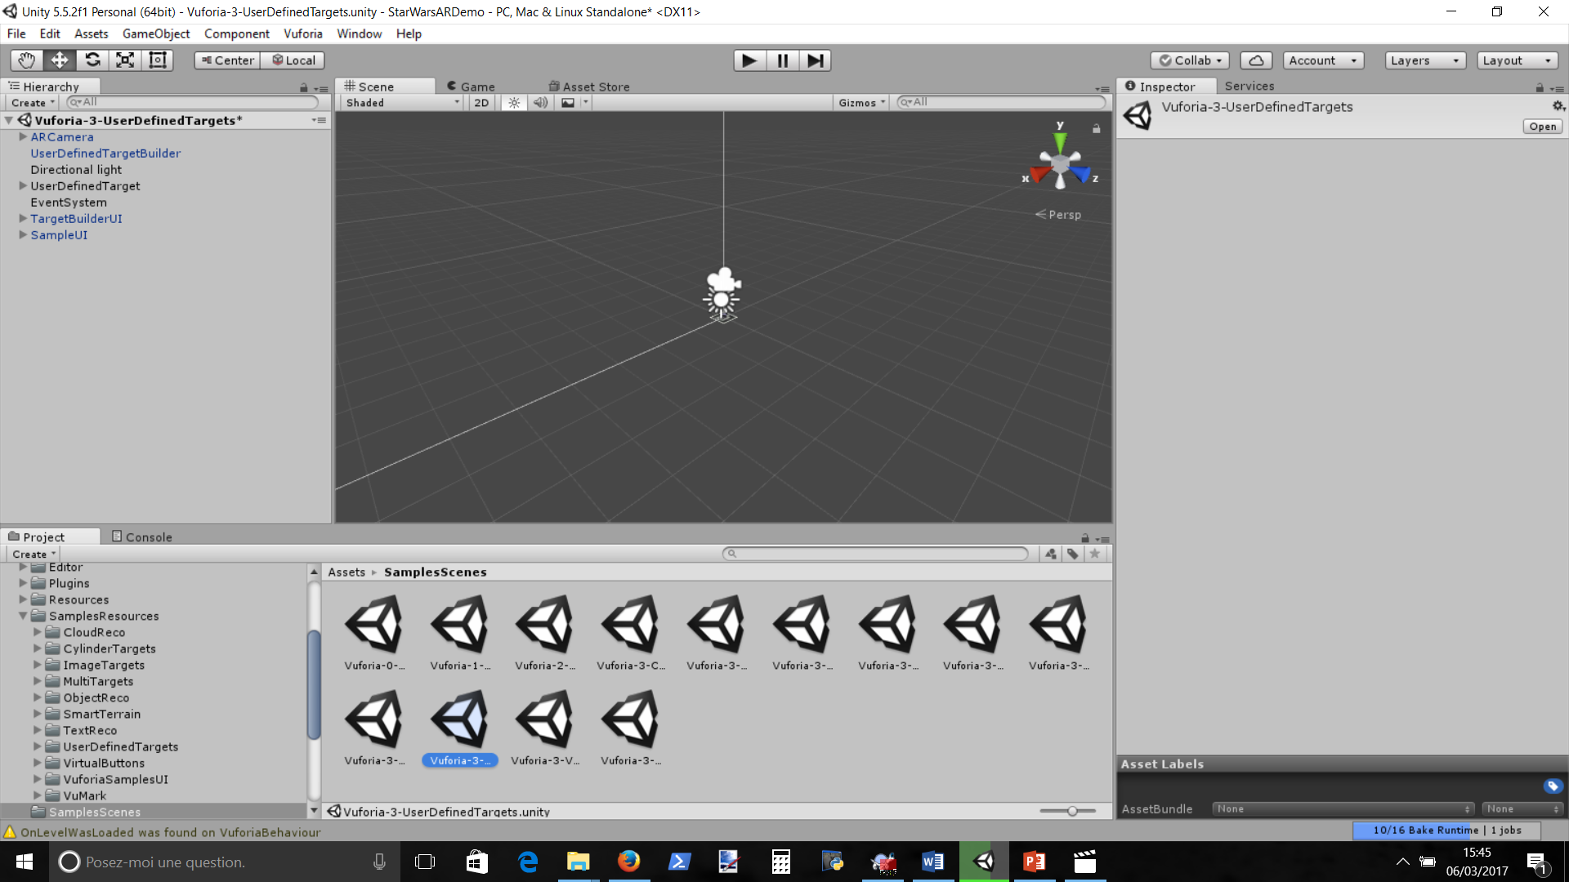

SampleScenes import vuforia userDefinedTarget by double clic

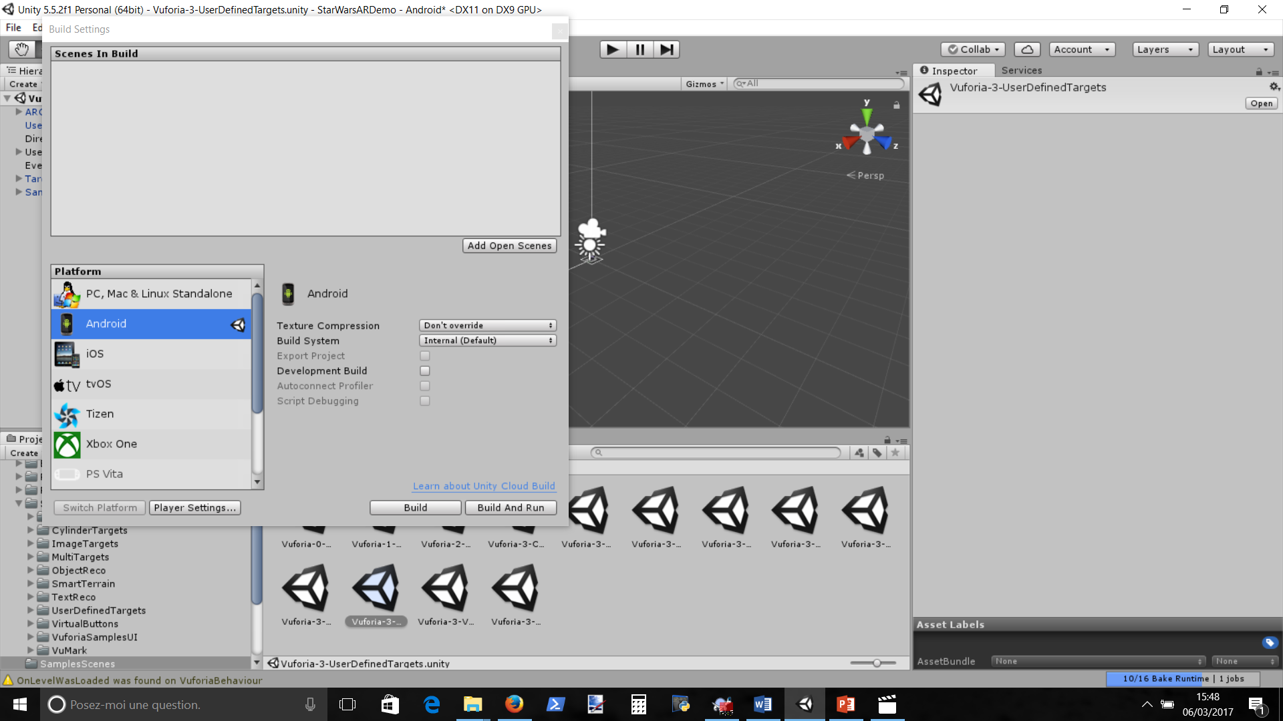

Change build setting to android -> then switch platform

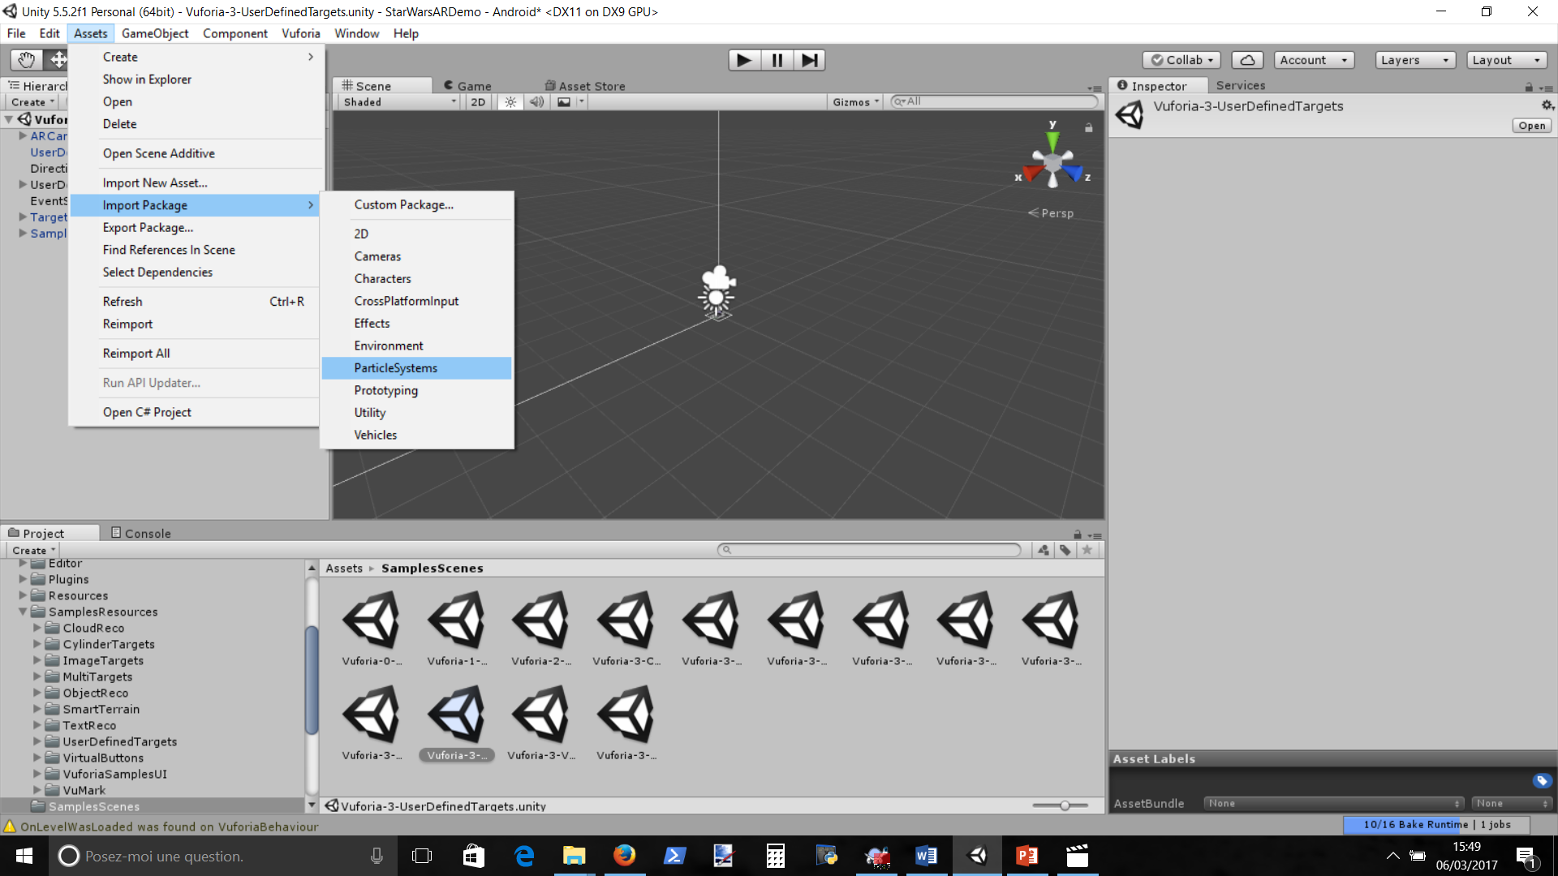

Import particleSystems asset for fog, etc…

Drag GameAsset in Asset folder

Add Vuforia Licence

Launch

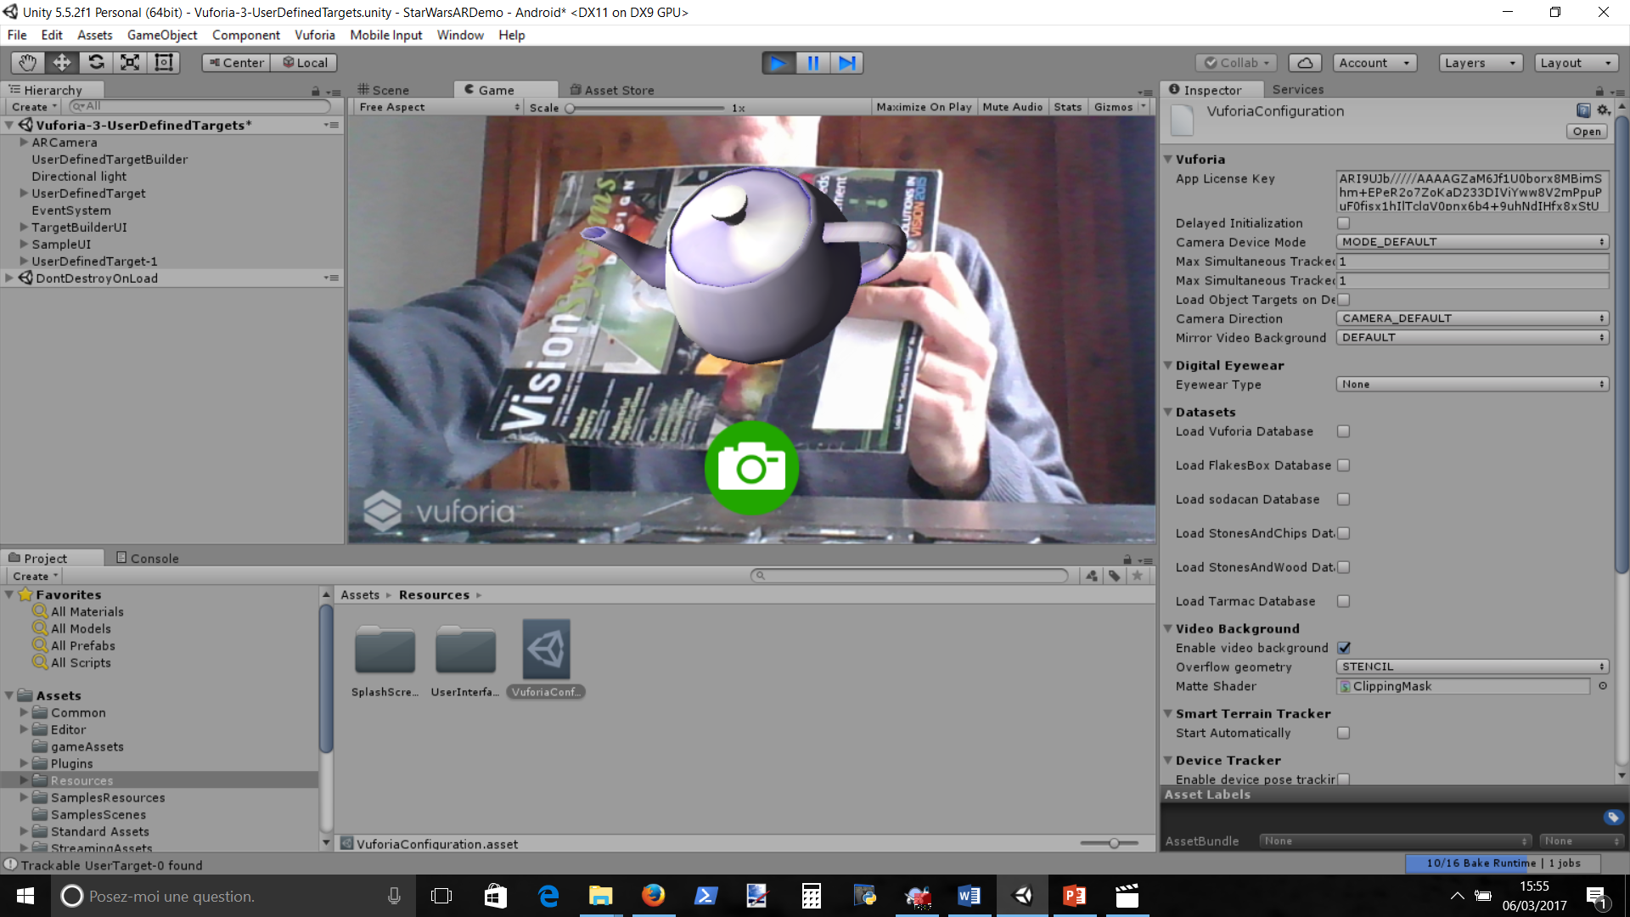

Launch with teapot

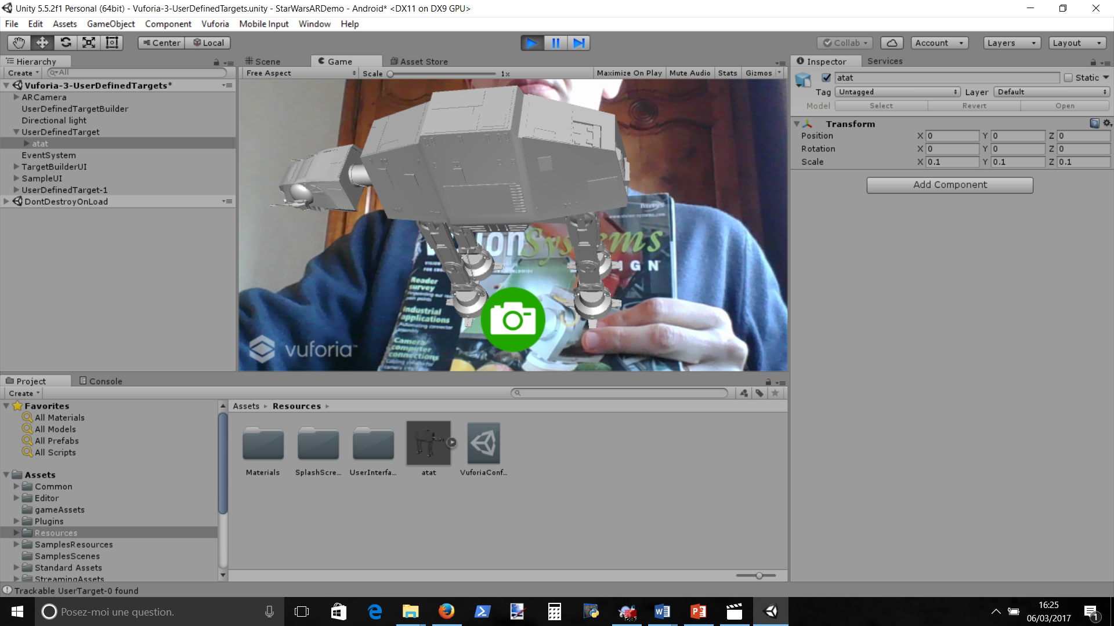

Change Teapot by Ata model in UserDefinedTarget

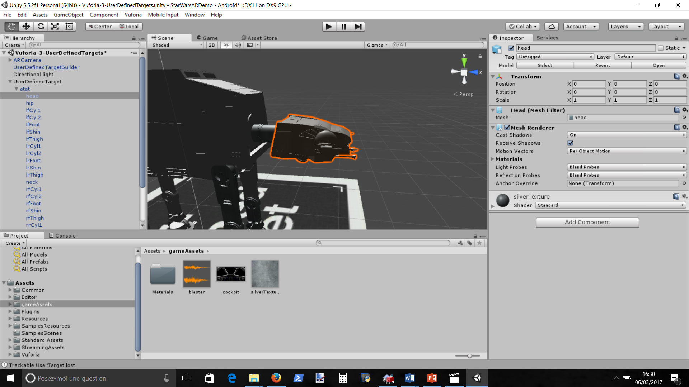

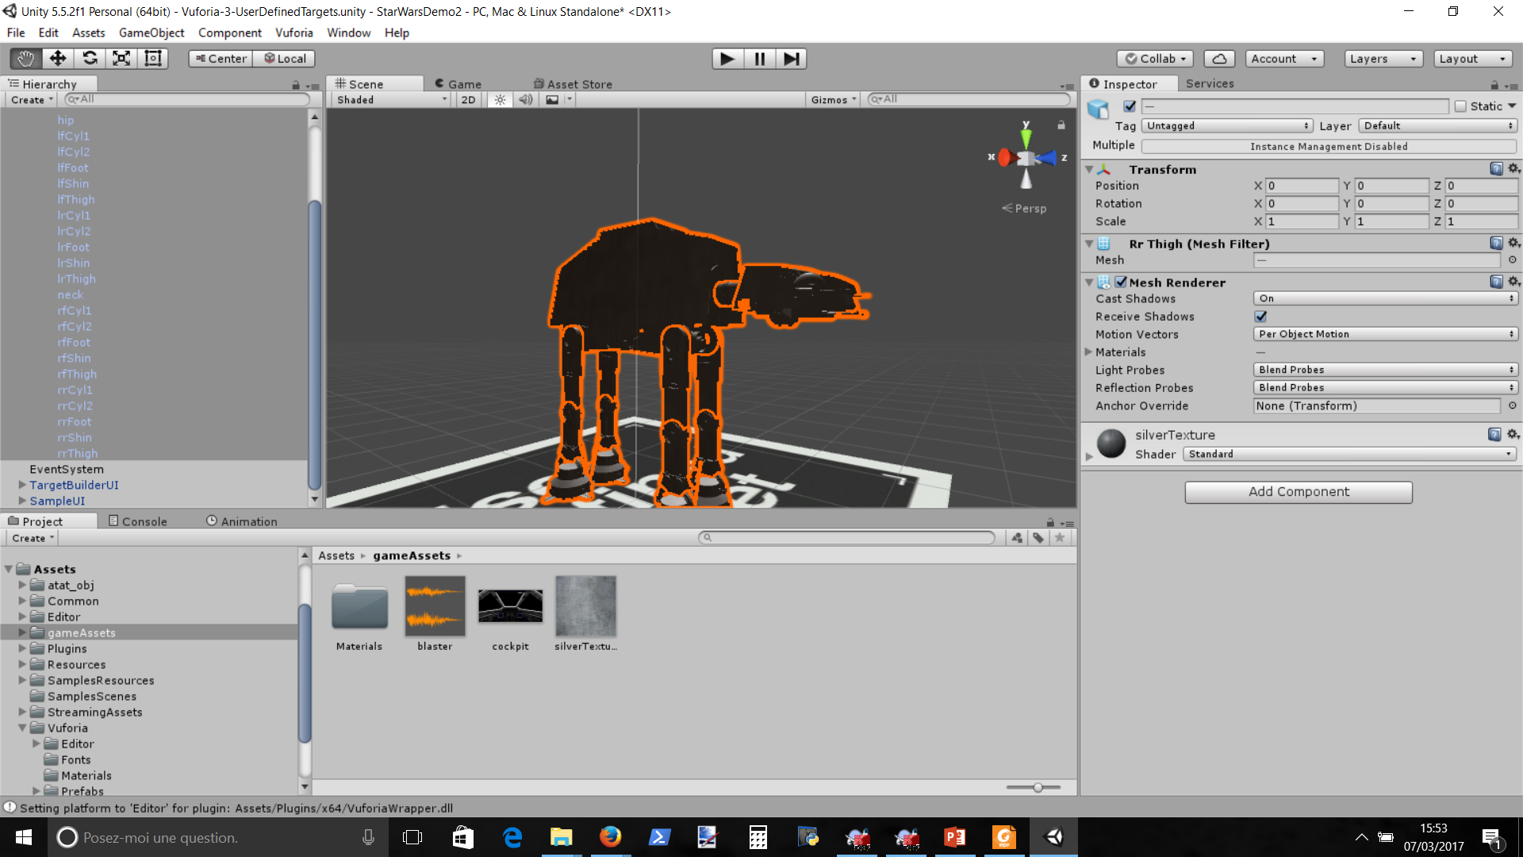

Texture the Object with silverTexture. Select all parts, drag and drop texture un inspector

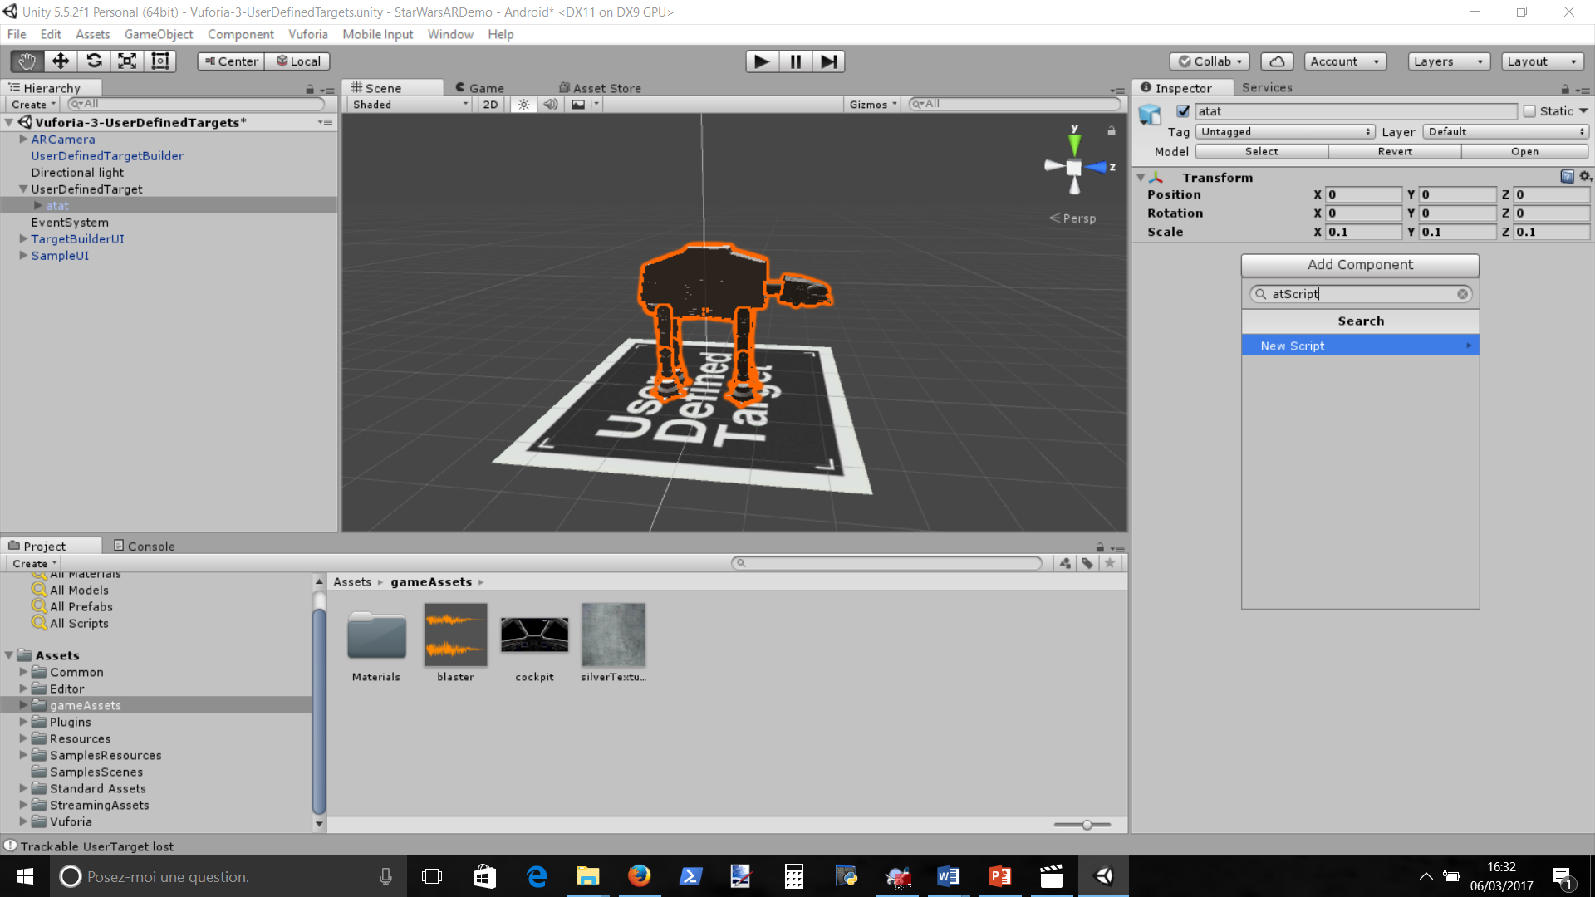

Add a new script atScript

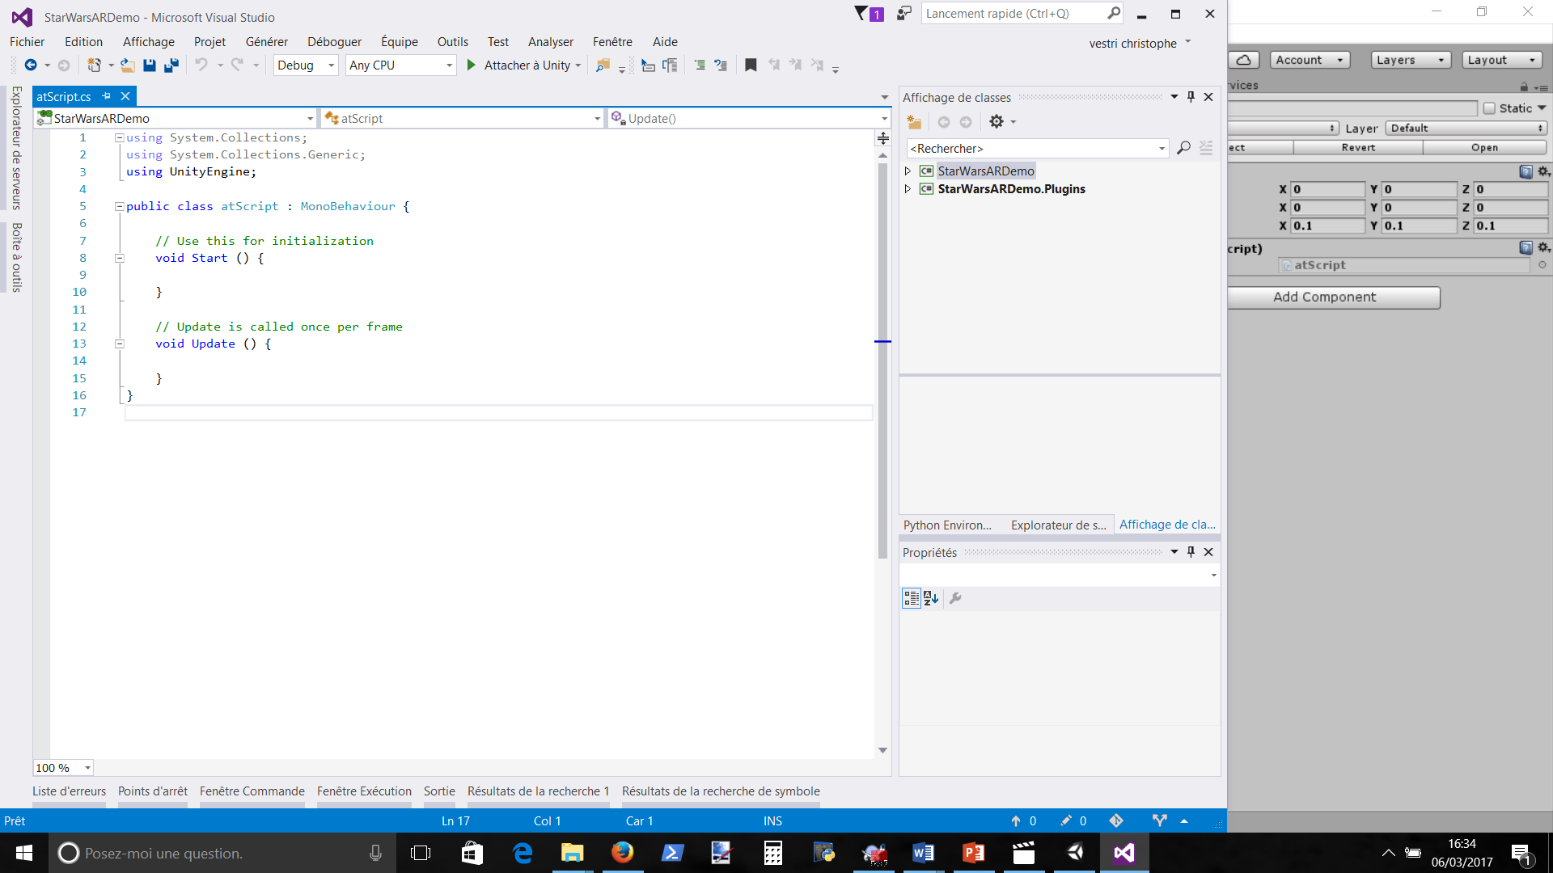

Edit it and put website code

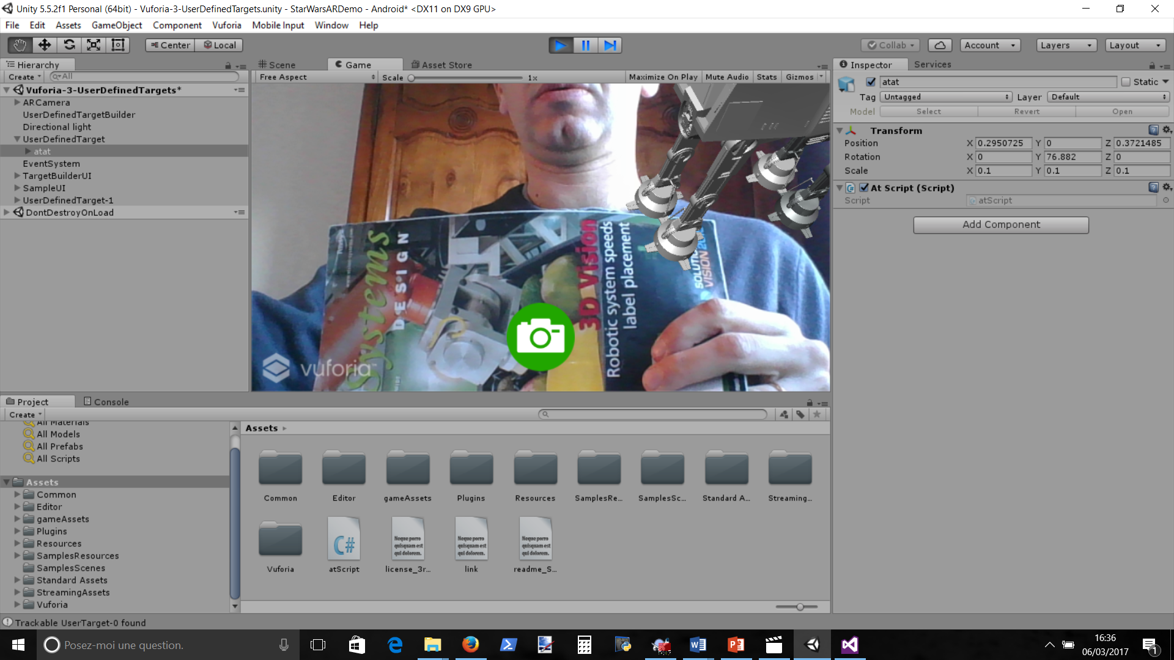

Now it moves (in circle)

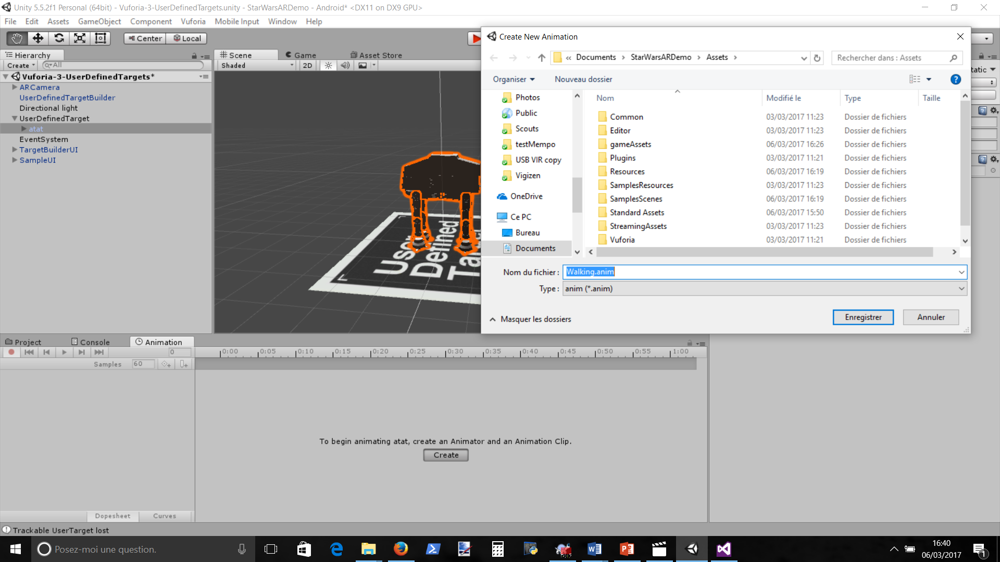

Animate it by clicking animation, and creating a new one

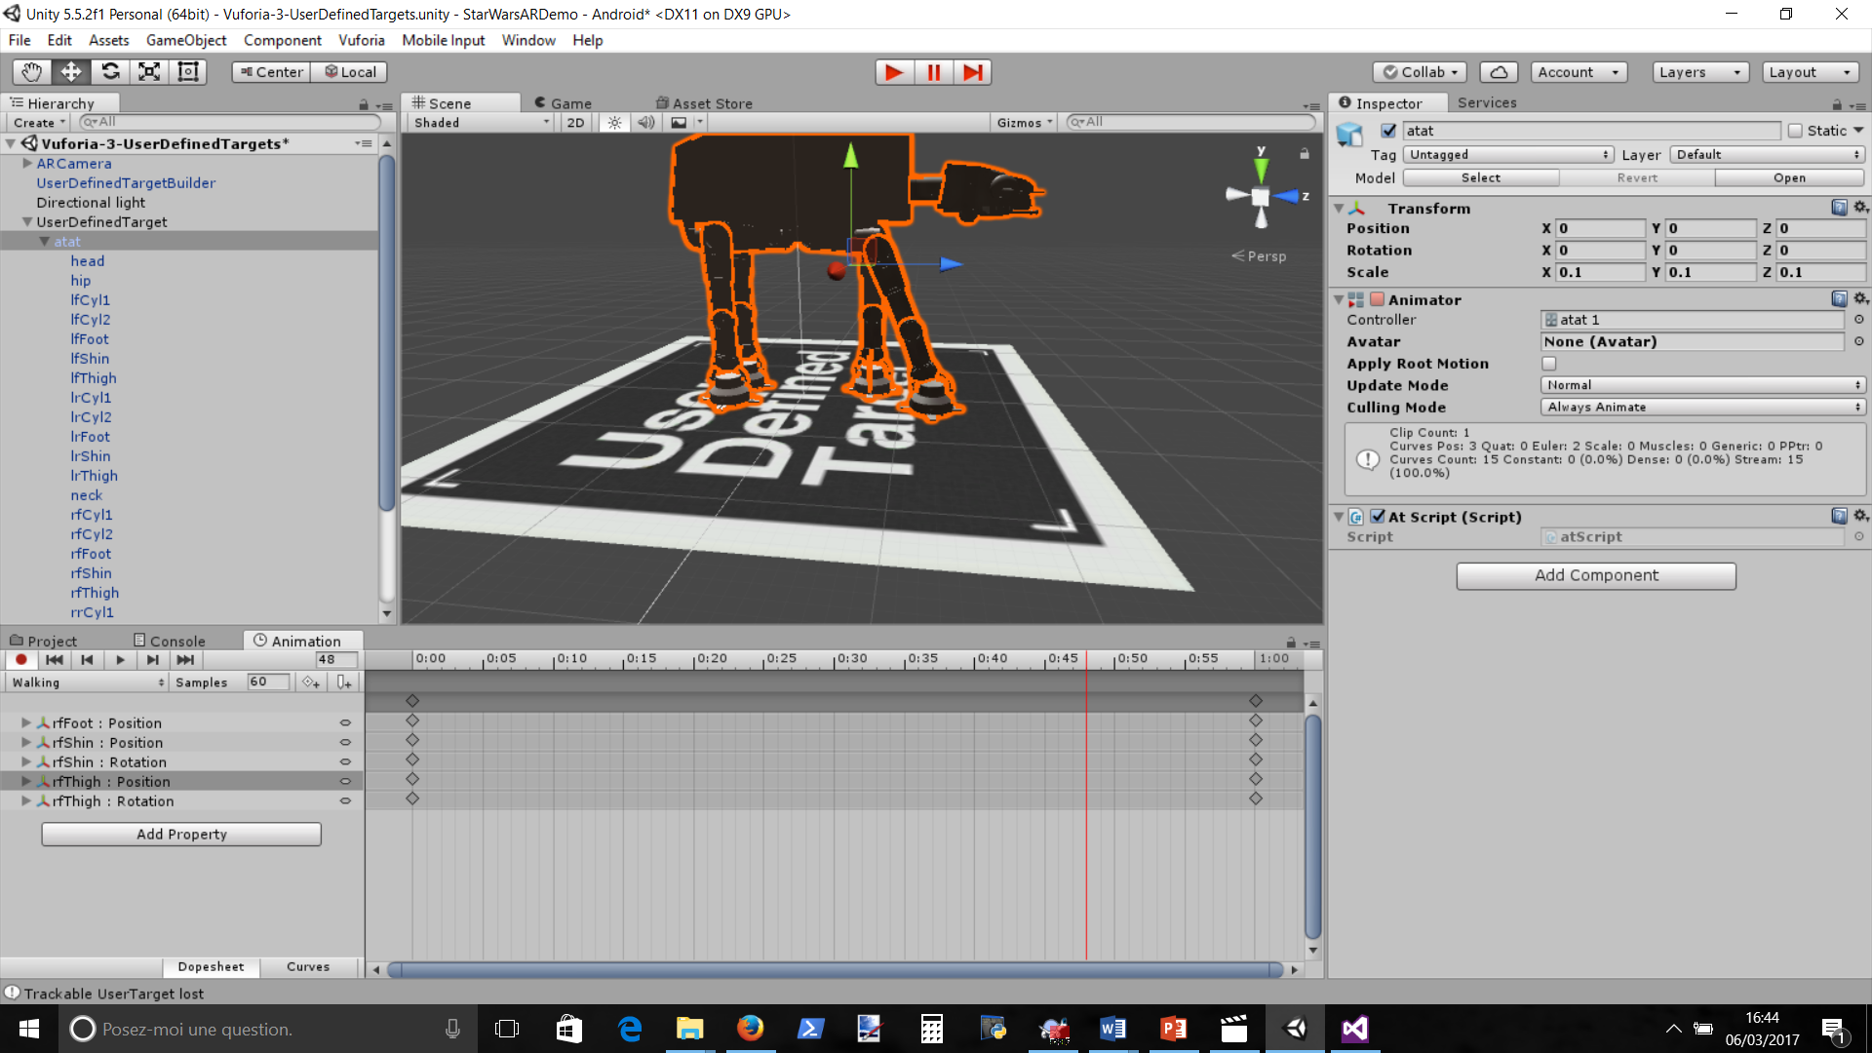

Move legs at 1s, 2s, 3s, and 4s keyframes

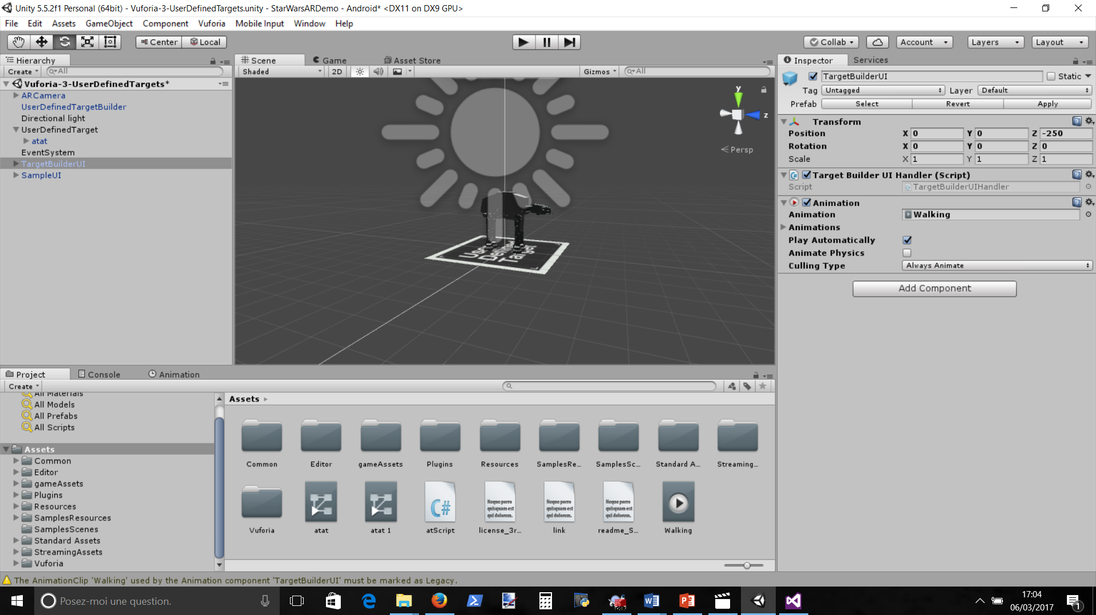

Remove Animation component and add a new with walking.anim (draganddrop)

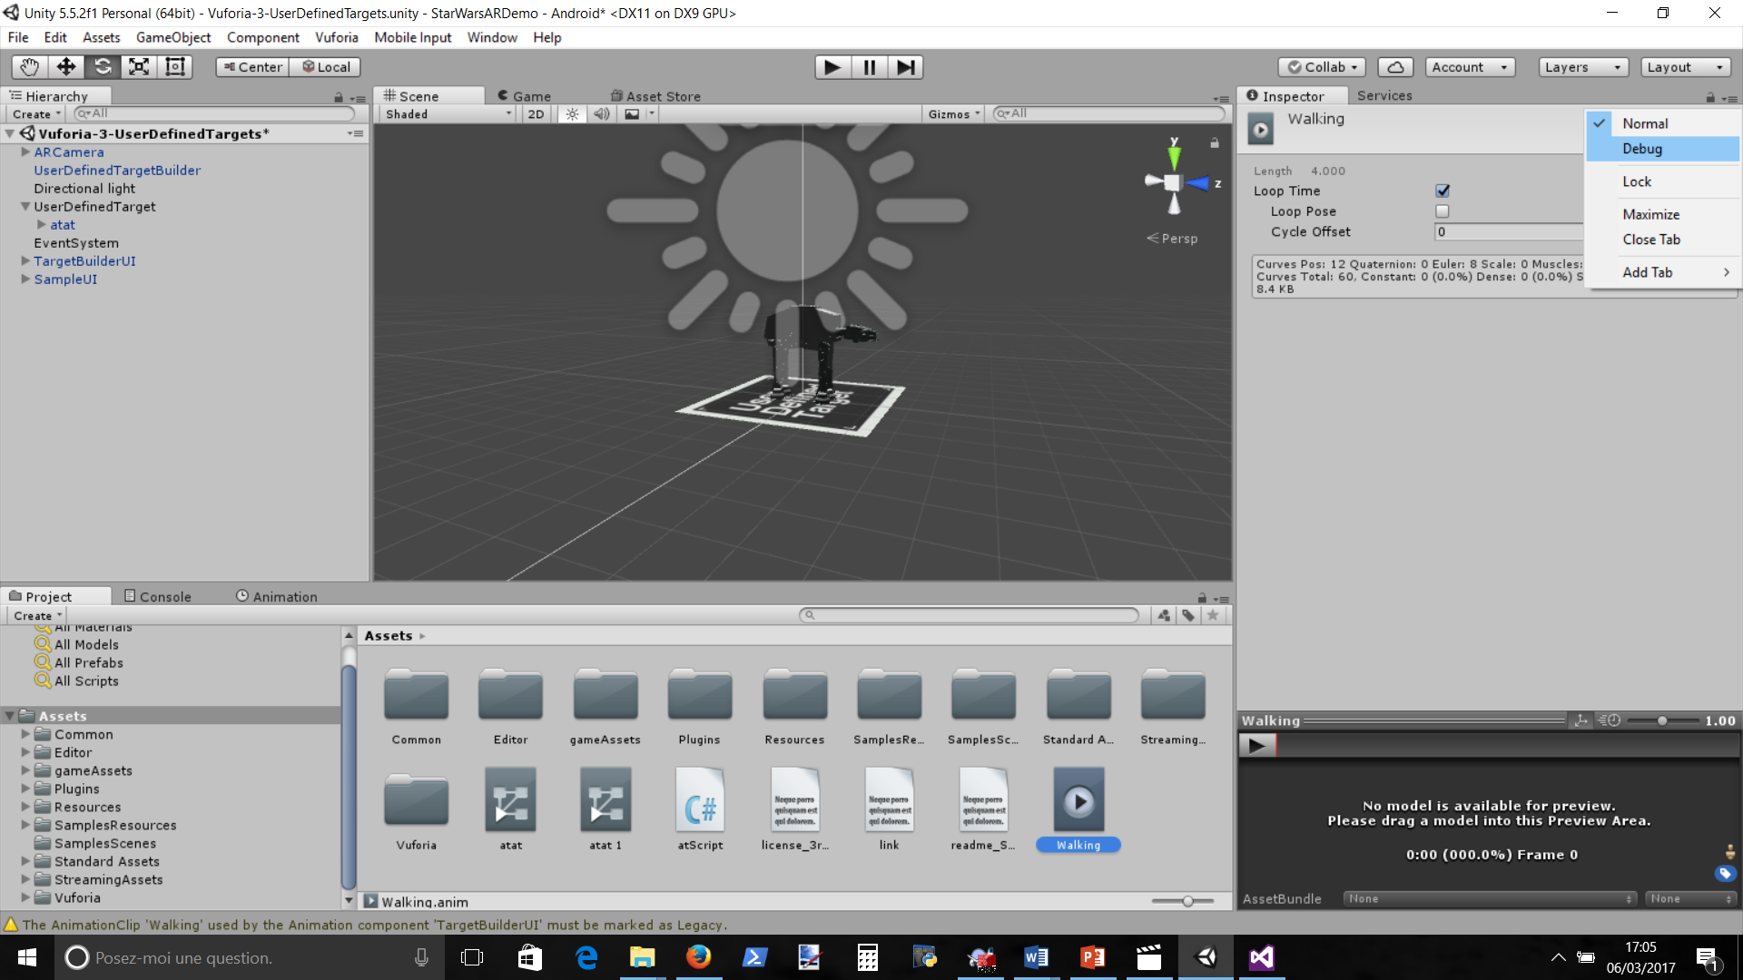

Put Walking in debub mode

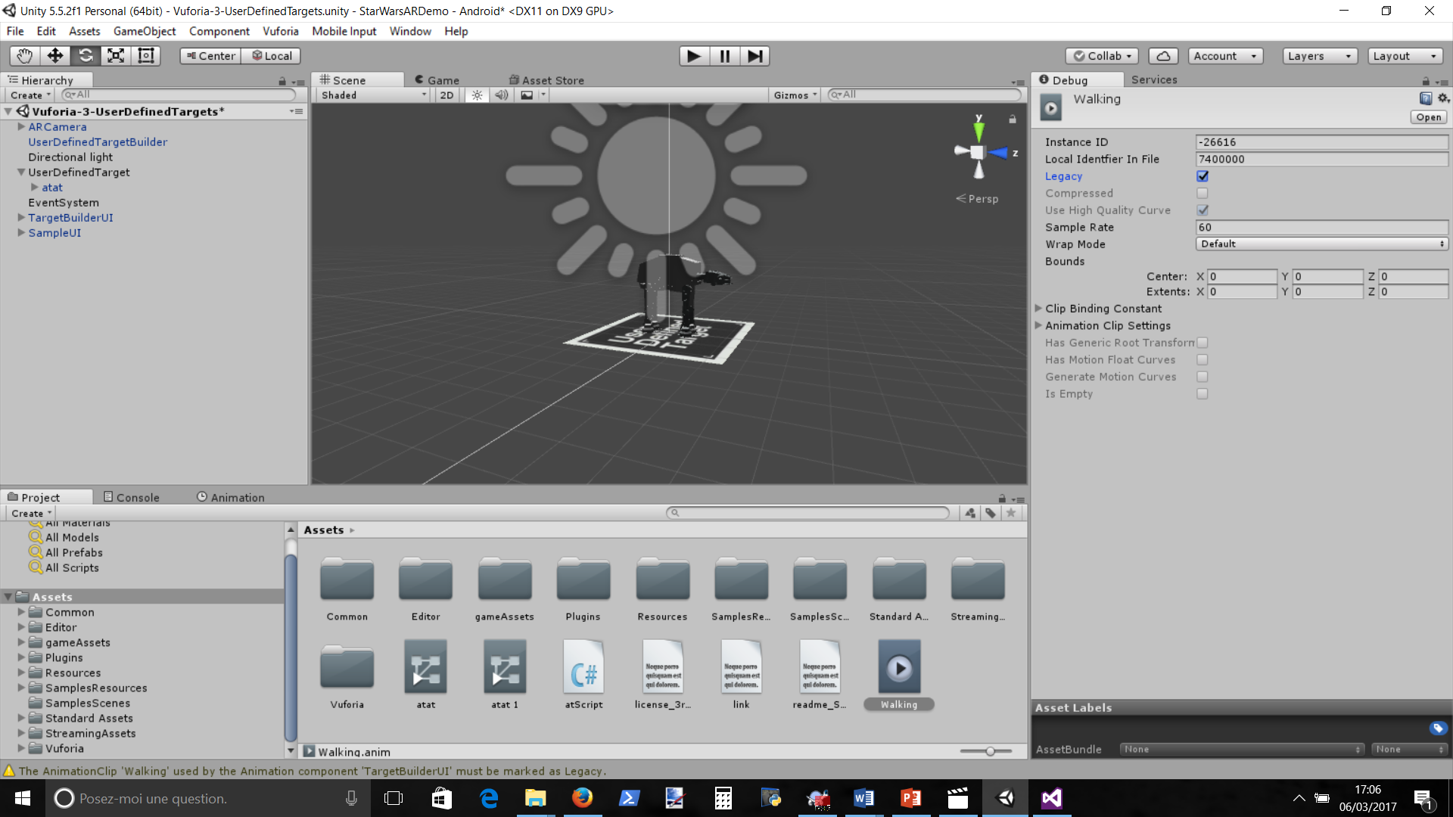

And click legacy

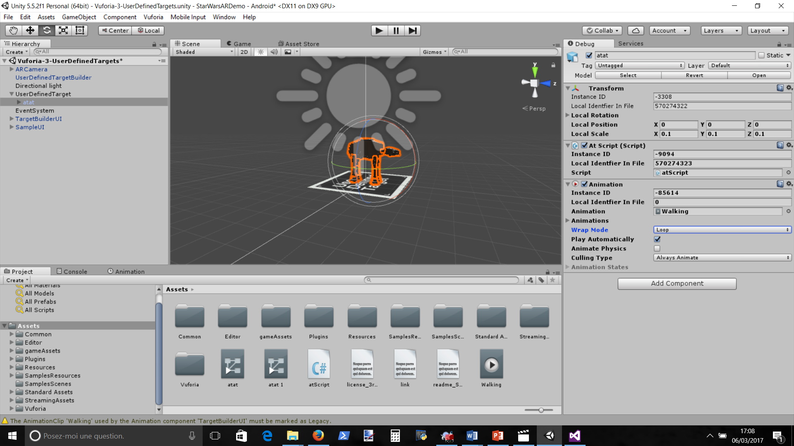

Click Atat, put in wrap mode=loop

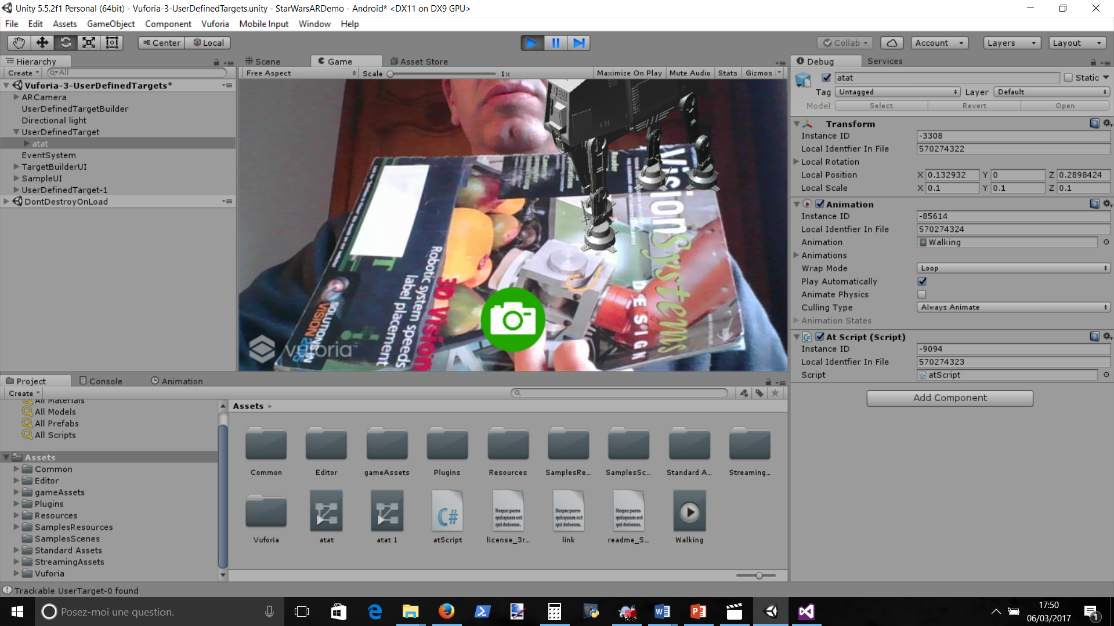

Now when playing it should move

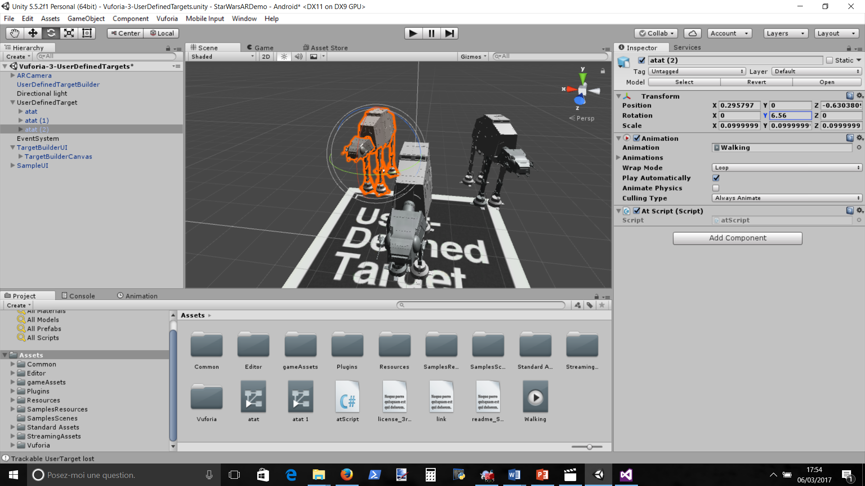

Add more atat, go back in normal mode

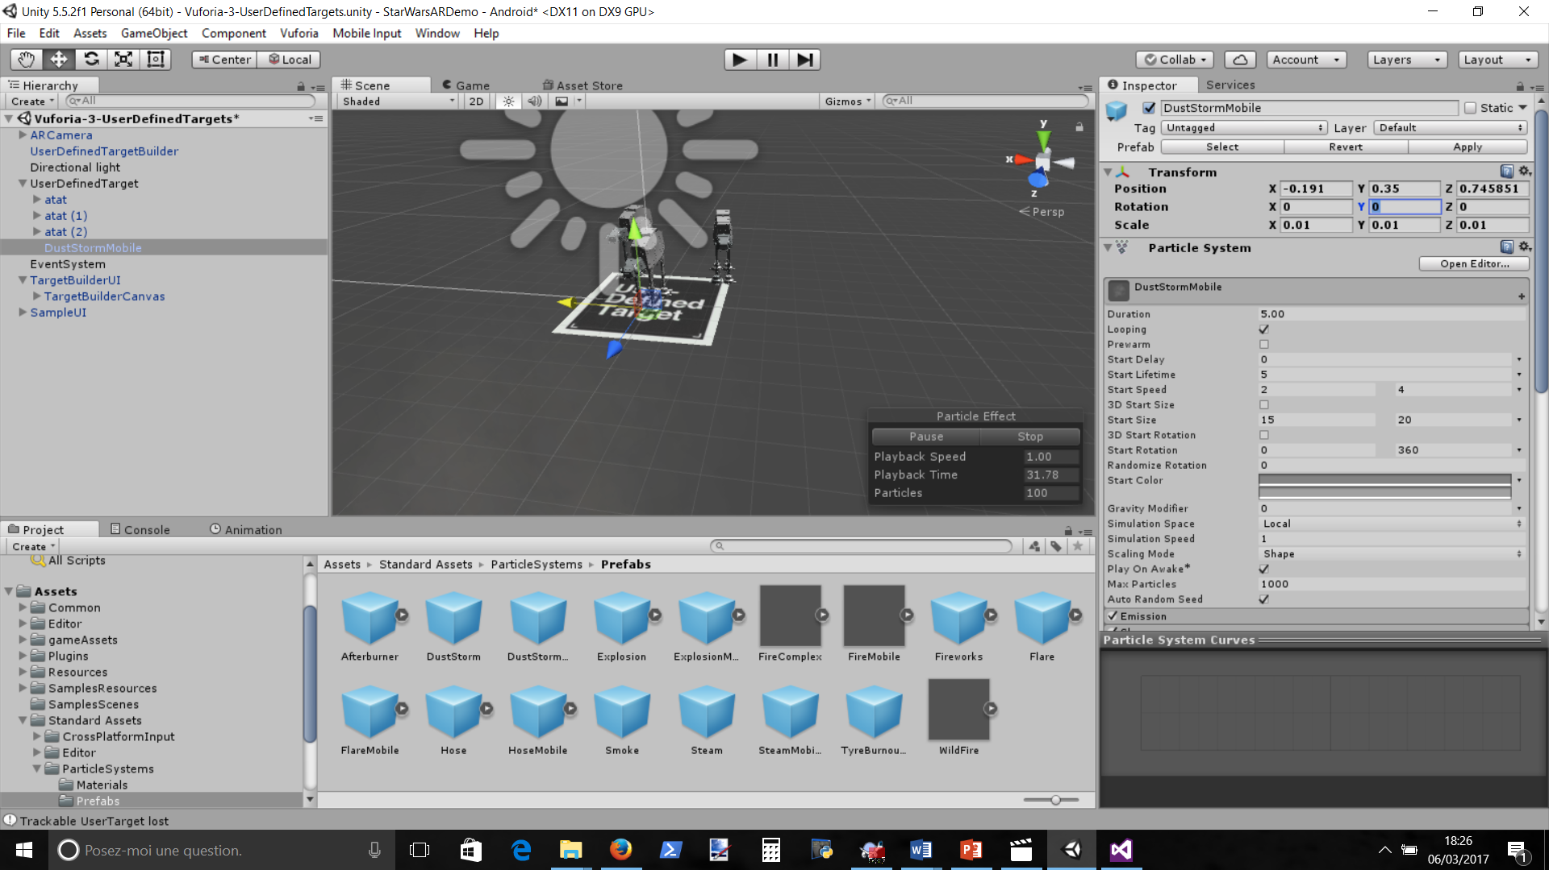

Add dust : Asset/standard Assets/particleSystems/Prefabs add DustStormMobile and put it in middle and tune to 0.01, can change color

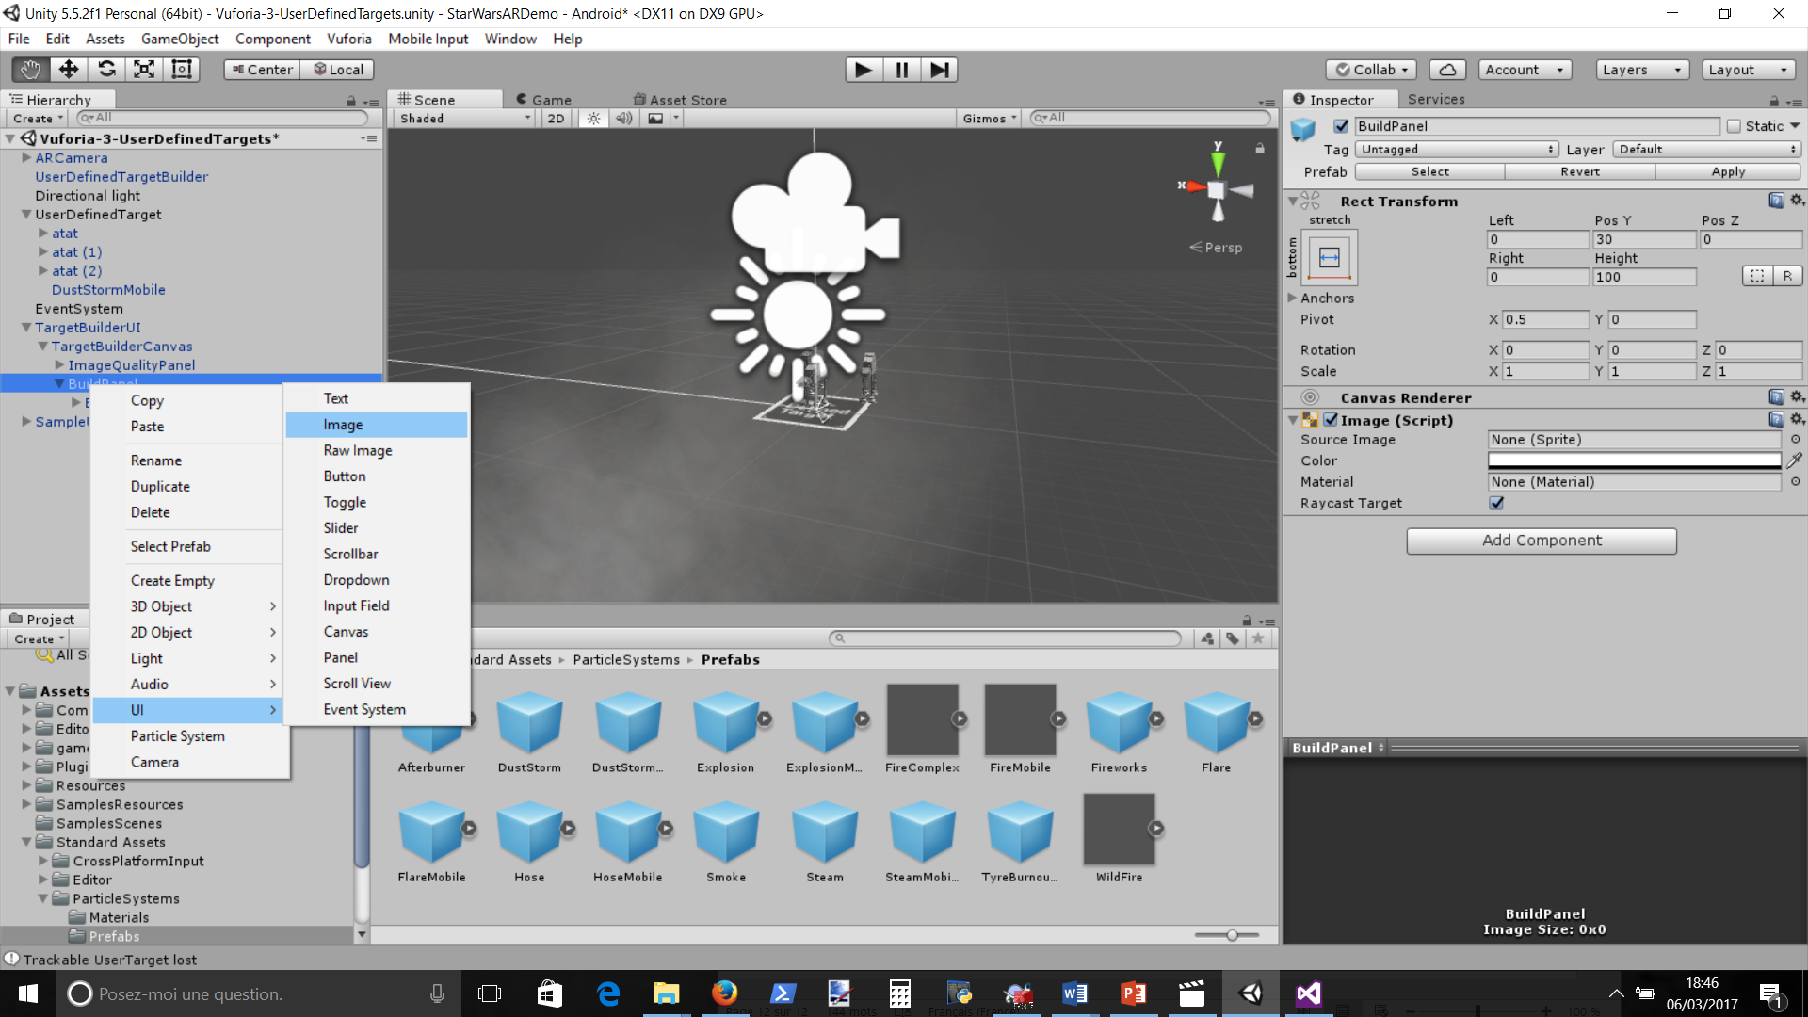

Add an image to Buildpanel for the Cockpit

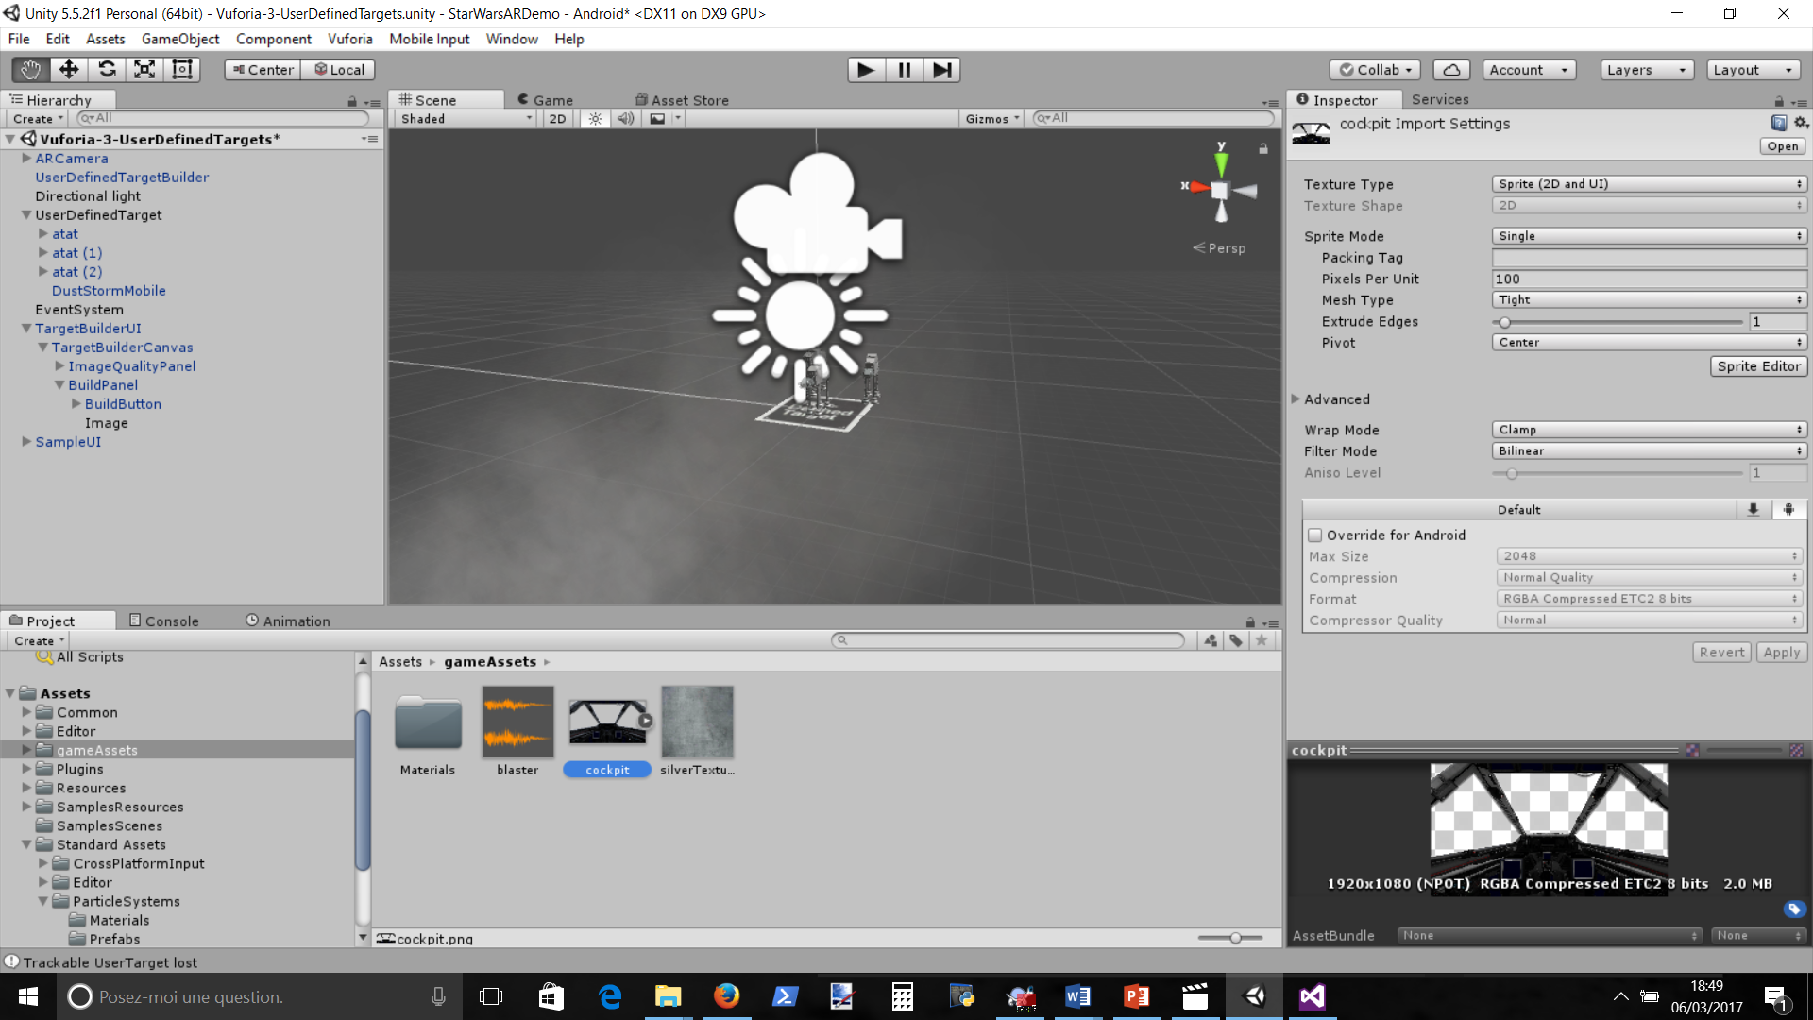

Select Cockpit image and put it in sprite and apply

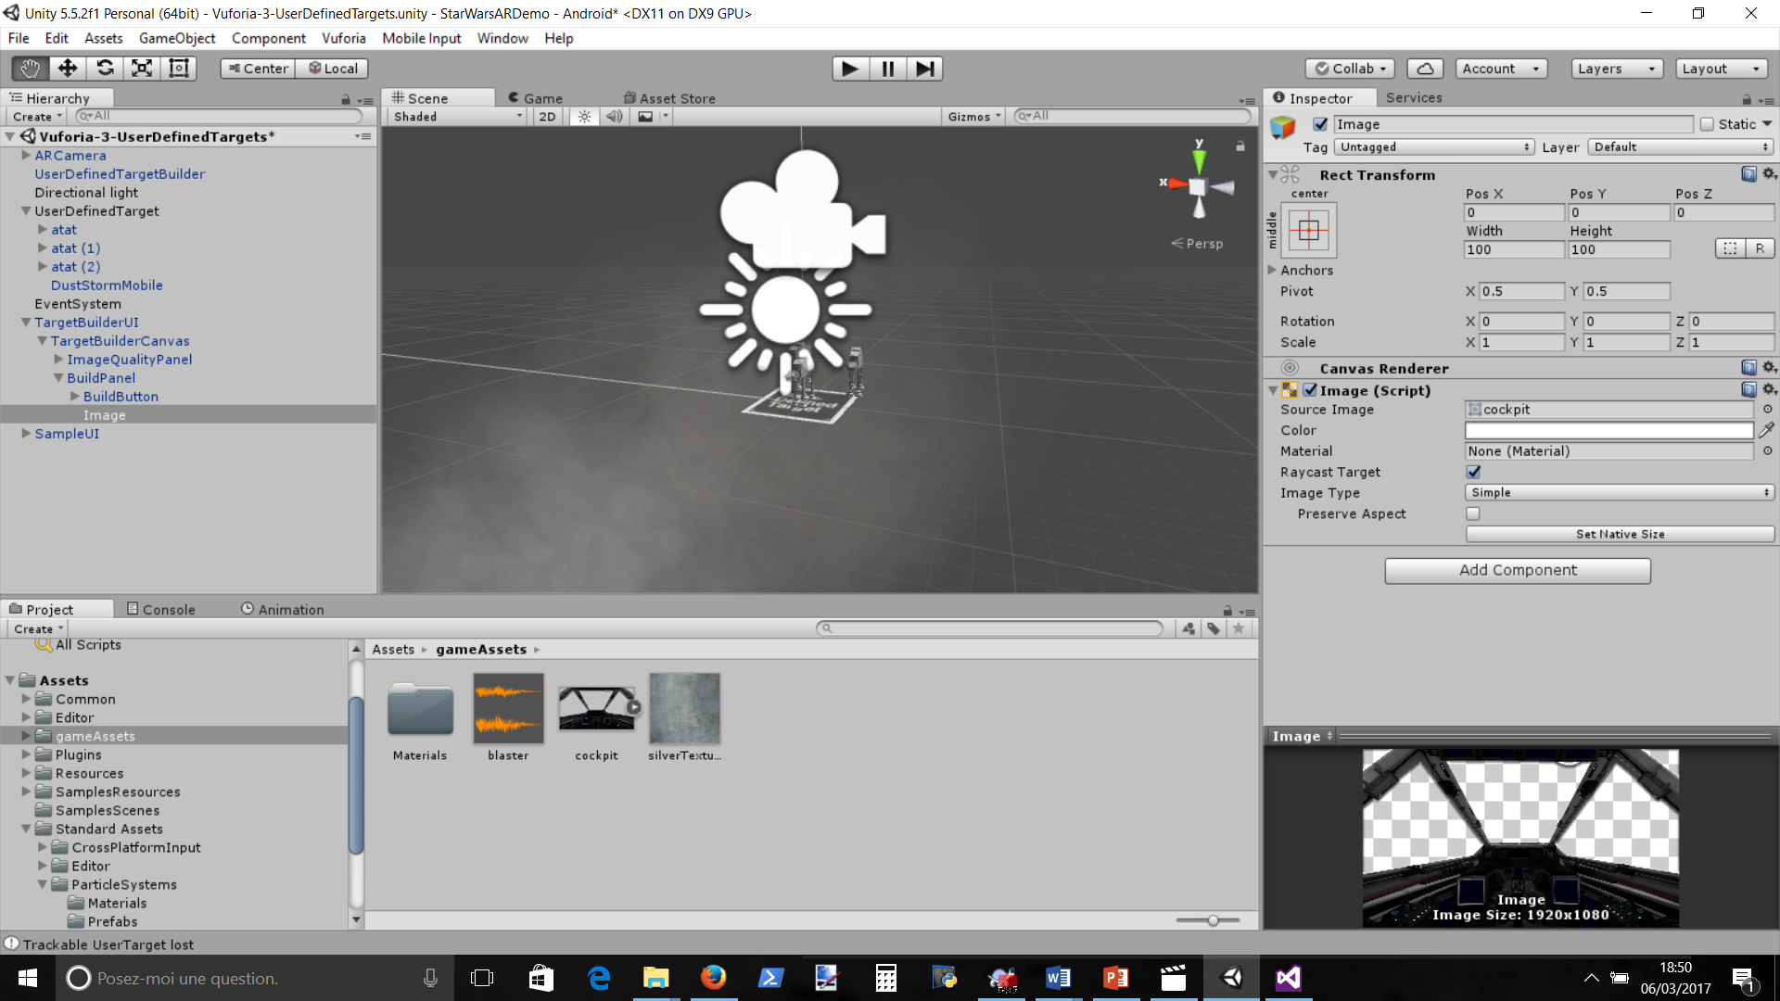

Select image, drag and drop cockpit and rescale

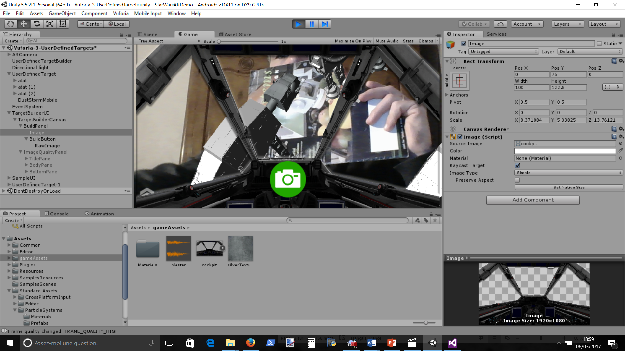

re-hierarchise the UI to have buttons above cockpit image

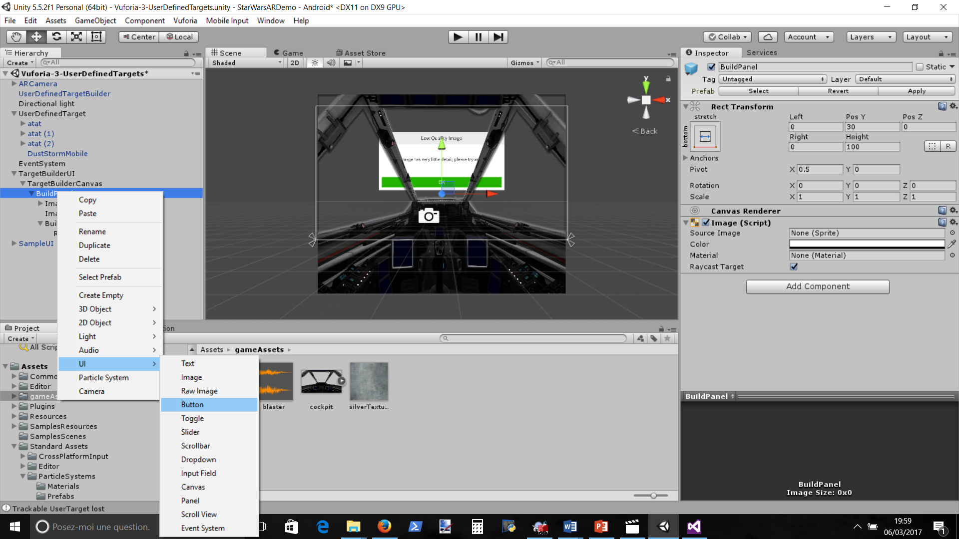

Remove green, put on side and create new button for lanching bullets

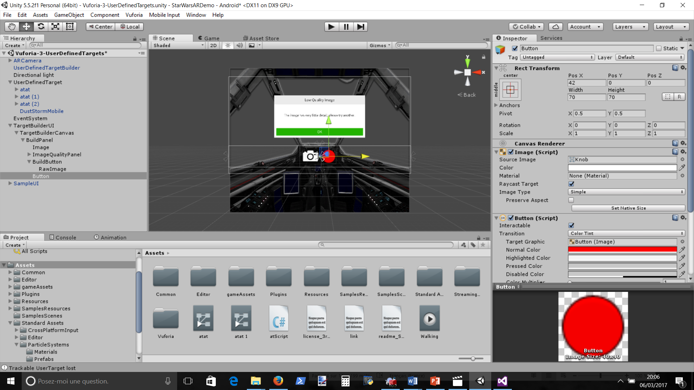

Change Sprite to Knob, color to red, remove text and resize

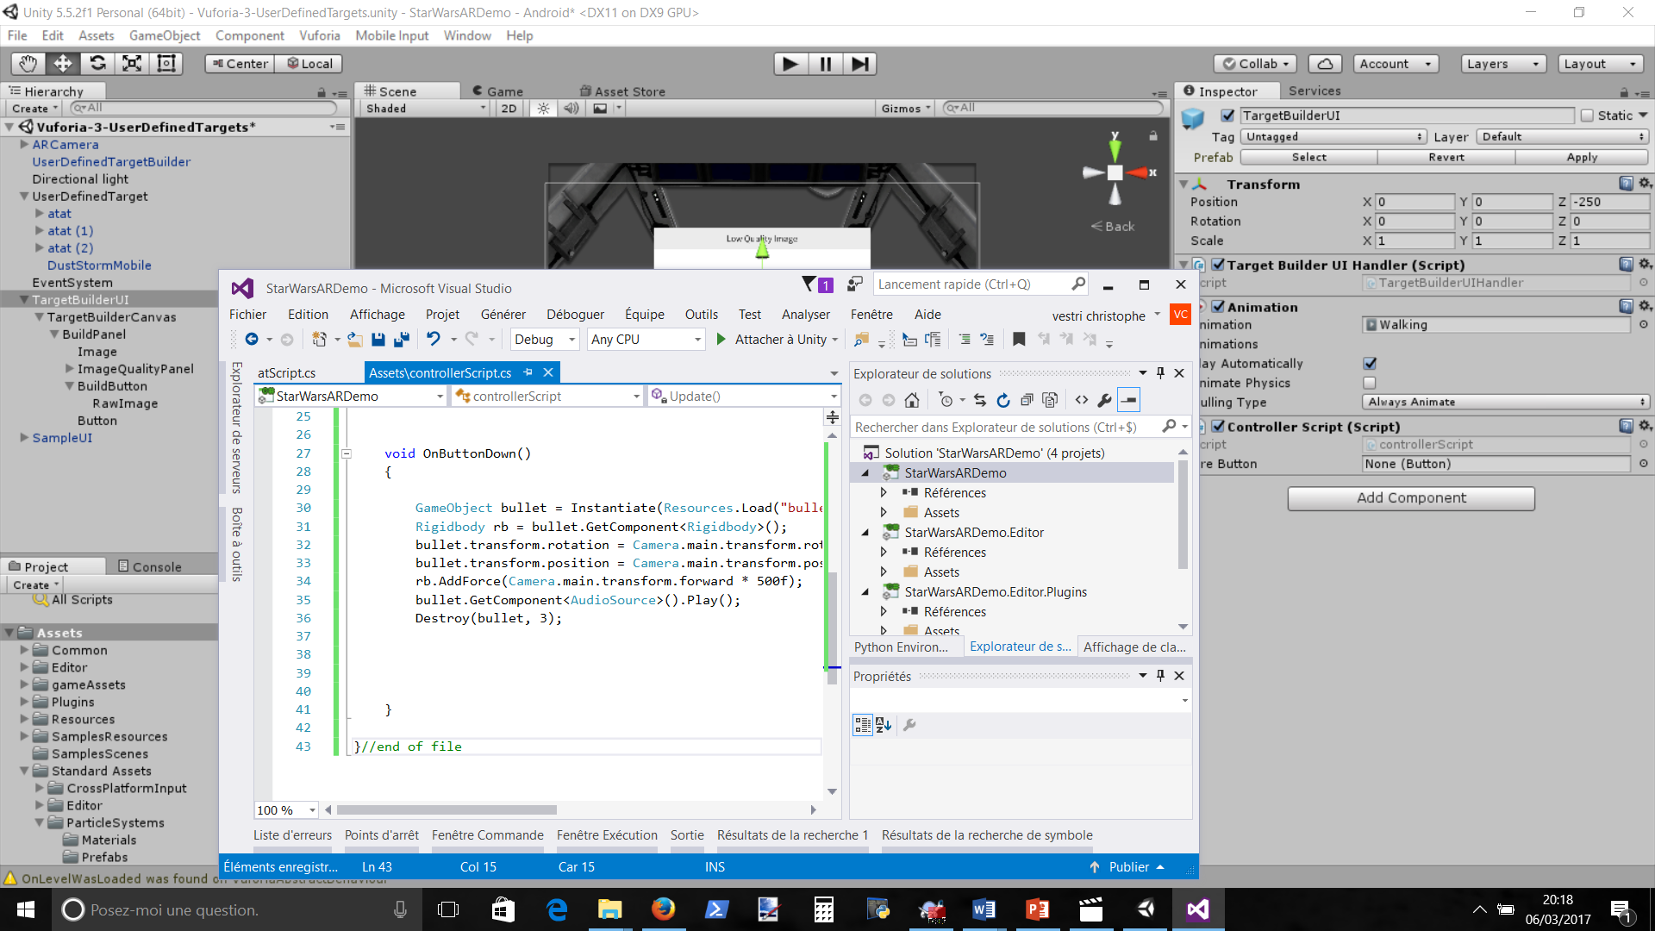

Click on TargetBuilderUI, add component, ControllerScript, Edit and copy and paste other website script

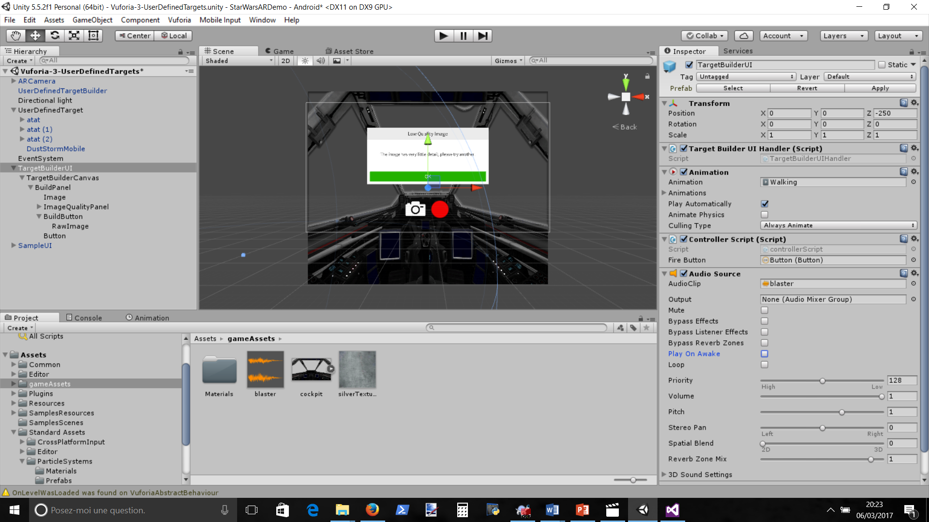

Drag button in FireButton, Add Audio Source (pas sûr : and put GameAsset/BlasterNoise in AudioCLip and uncheck play on awake)

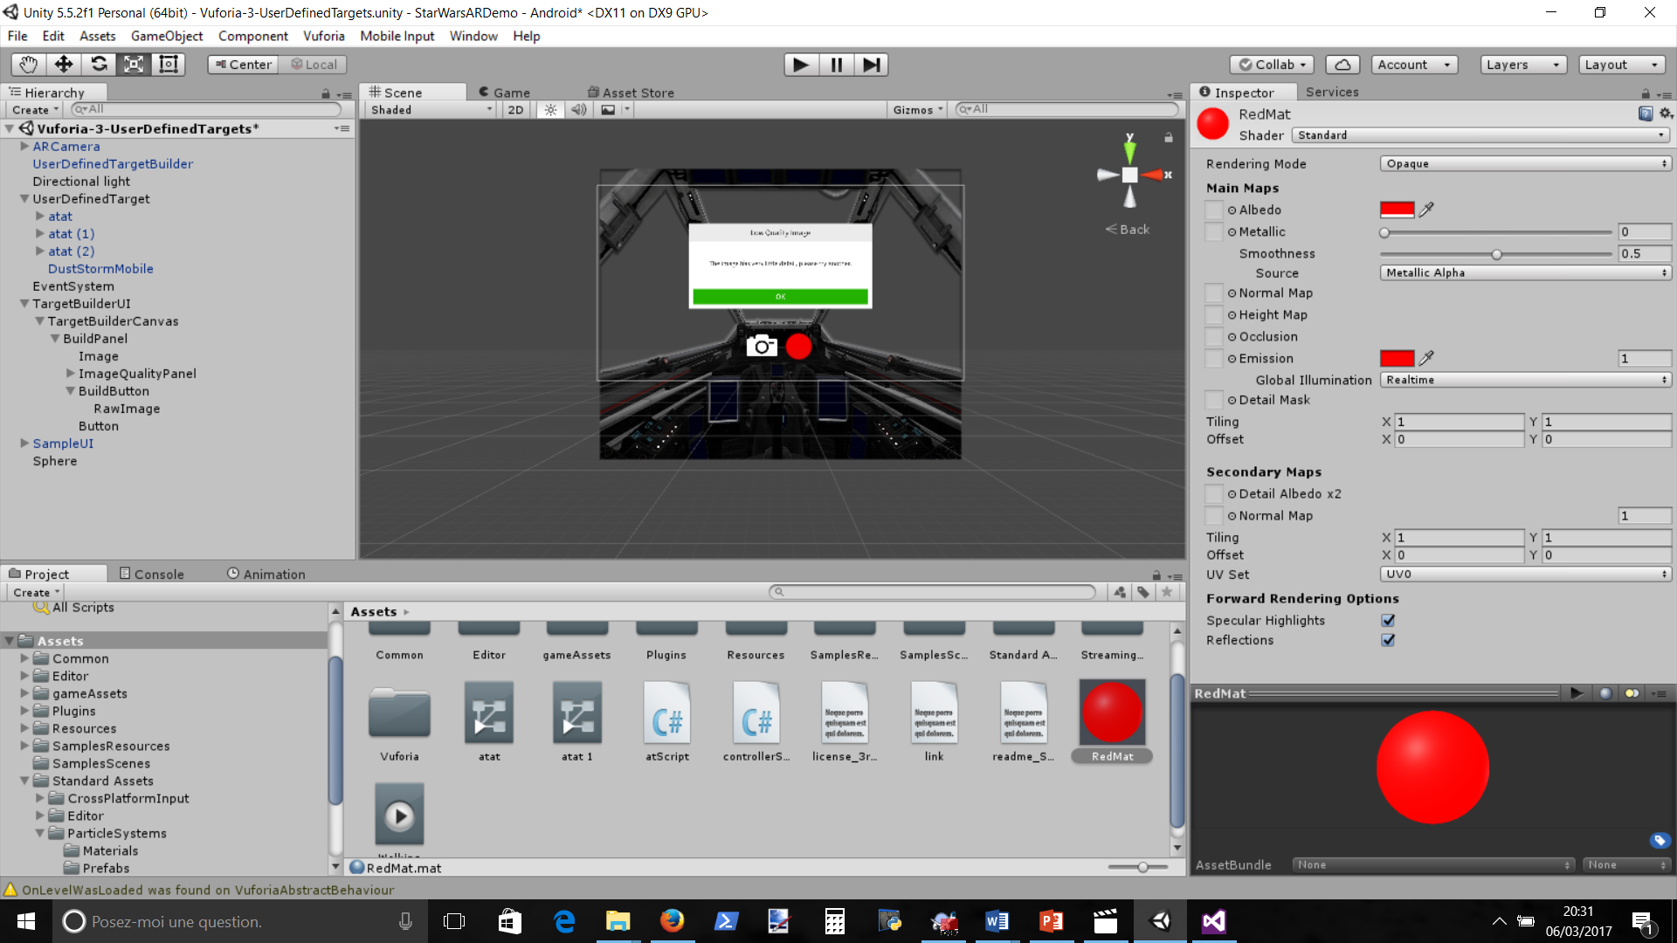

Create RedMat for red material and a sphere on the scene,

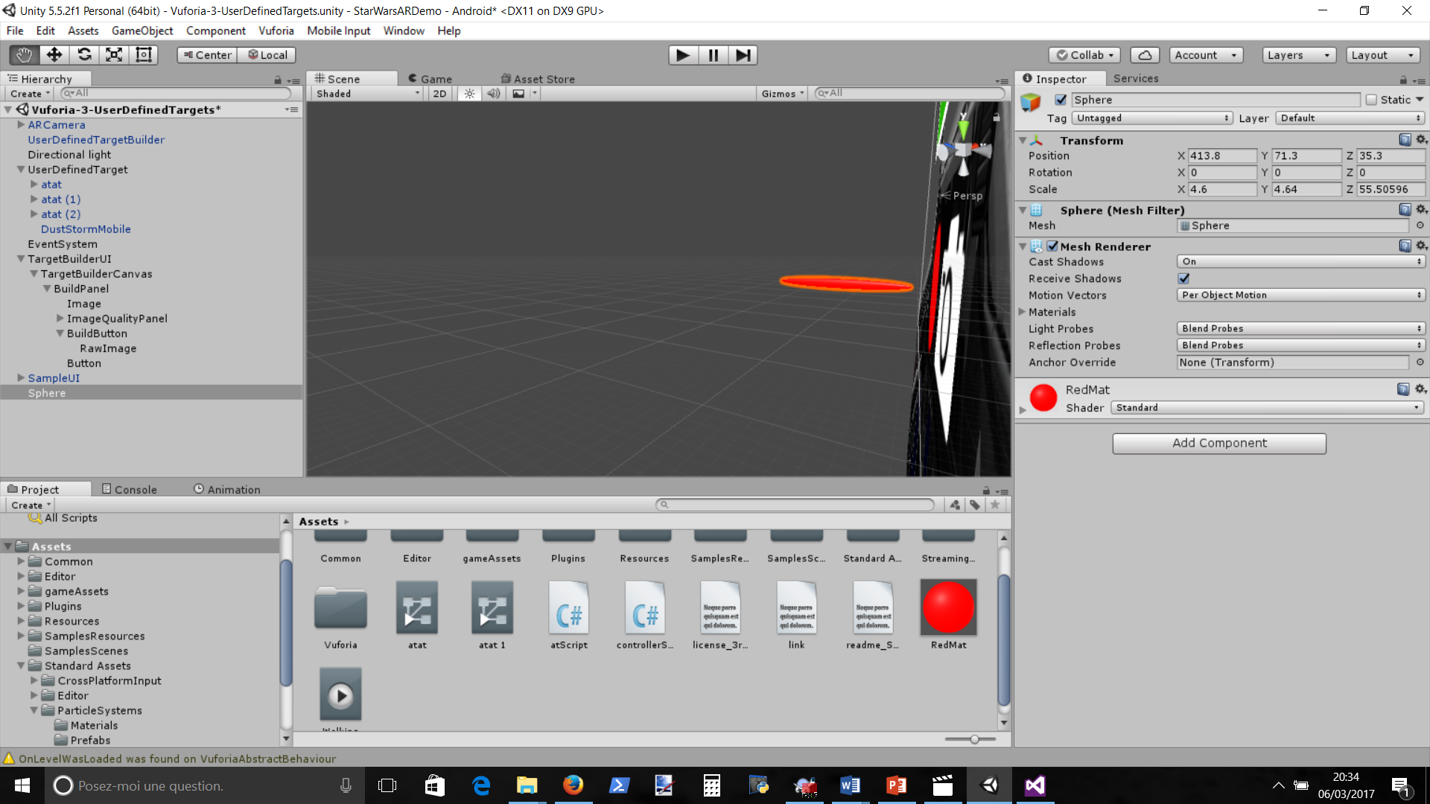

put material on the sphere and change z-size to have a red bullet shape and remove collider sphere component

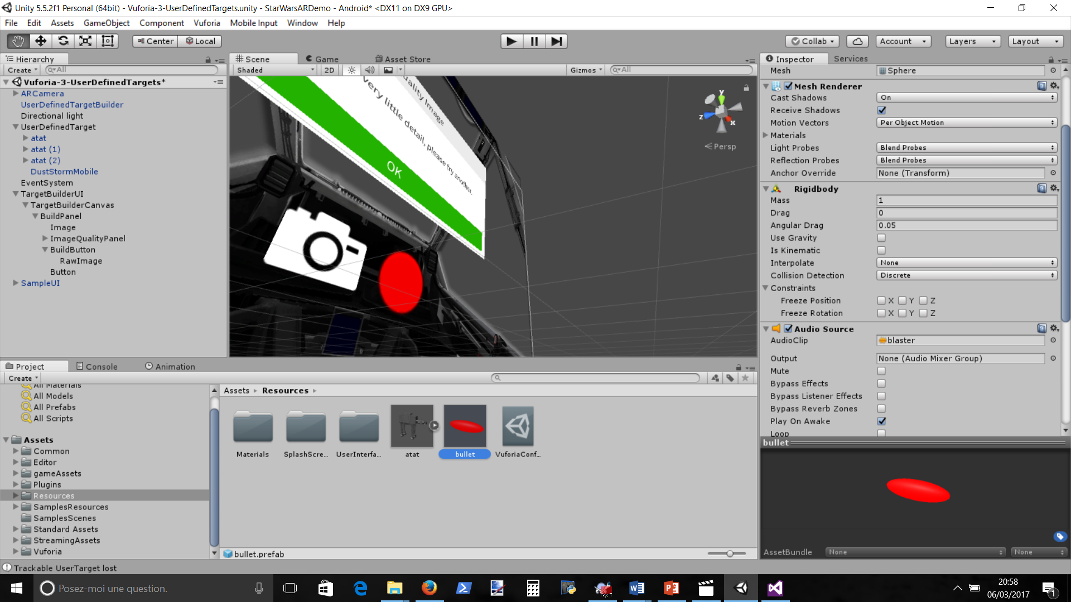

Add rigidBody component and uncheck gravity

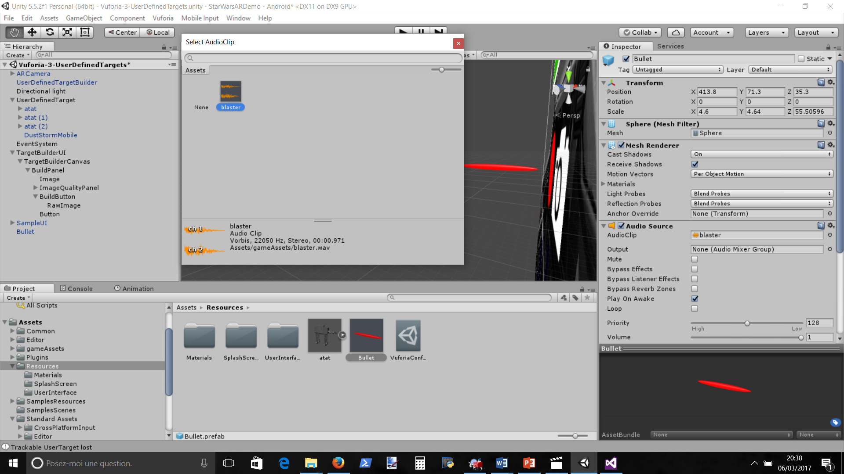

Move Sphere in ressource and rename it bullet, add audiosource component and add Blaster sound

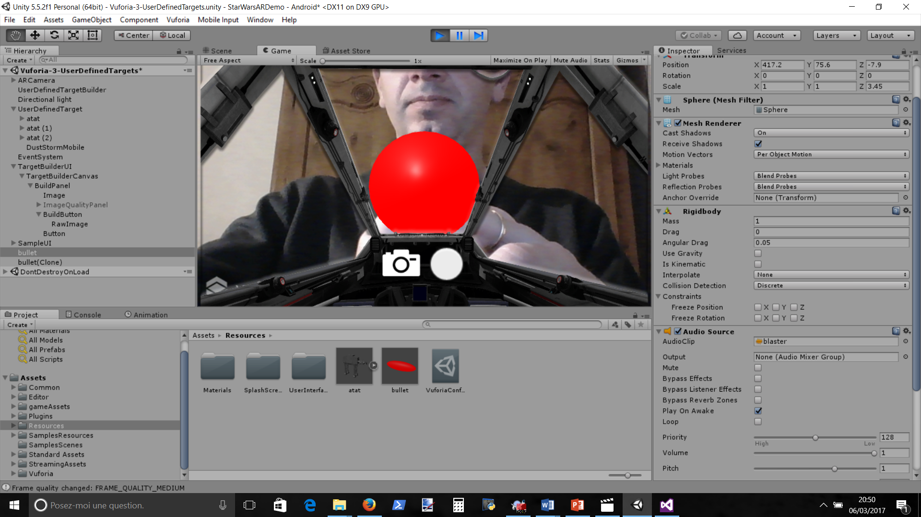

That’s it